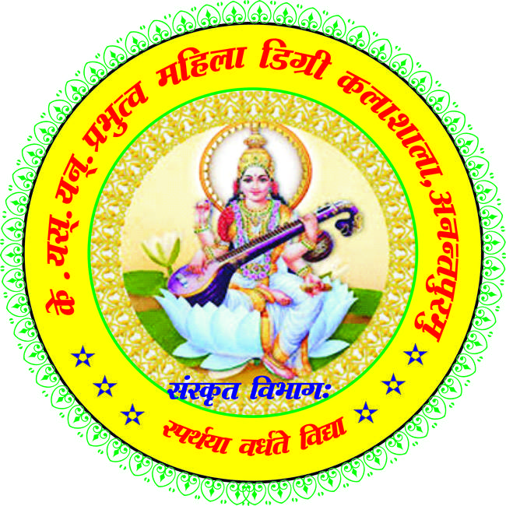

|  |  |  |  |  |
| --- | --- | --- | --- | --- |
| **S.No** | **Date** | **Title of the  Activity** | **Details of the Resource Person** | **No. of Students Participated** |
| 1 | 12-01-2021 | SAMSKRANTHI SAMBARALU | Radheya, Rtd Telugu Lecturer | 240 |
| 2 | 05-02-2021 | VISISHTA ATHIDHI POOJA | Sri. DattatrayaVajrahalli | 150 |
| 3 | 18-08-2021 | Bhashavibhavam | Sr.A.Subbanna | 80 |
| 4 | 22-10-2021 | ADI KAVI JAYANTHI | Dr.Ramanjaneyulu | 100 |
| 5 | 07-12-2021 | VANABHOJANAM | ALL STAFF MEMBERS | 50 |
| 6 | 16-12-2021 | BHAGAVADGEETA VIBHAVAM | SWAMY ATMAVIDANANDA(CHINMYA MISSION | 250 |
| 7 | 18-12-2021 | KANDUKURI KAVYA DWAYAM | Dr.M.Praphulla, J.SyamasundraraSastry | 400 |
| 8 | 22-12-2021 | NAVA RATNALU-NAVA SAKANIKI NANDI | SAILAJA, APSRTC ZONAL CHAIRMAN | 400 |

|  |  |
| --- | --- |
|  |  |

SAMSKRANTHI SAMBARALU12-01-2021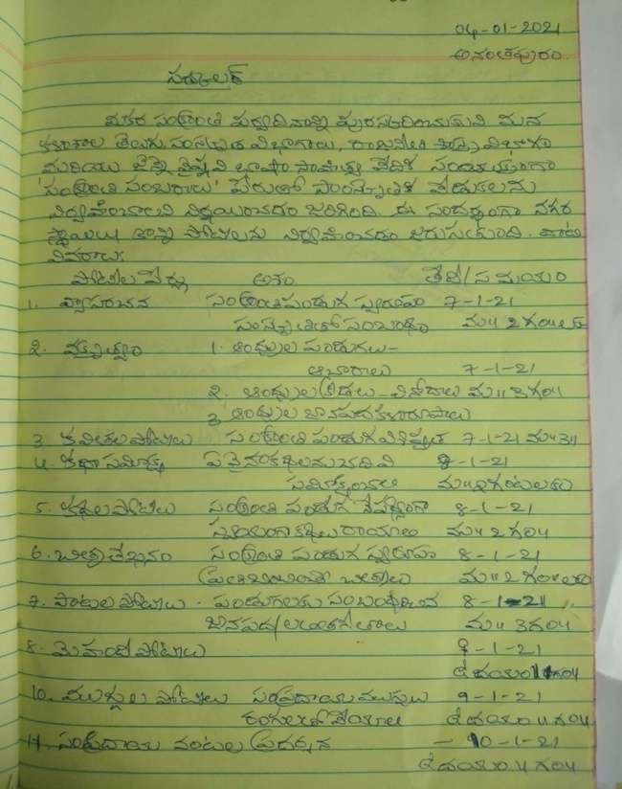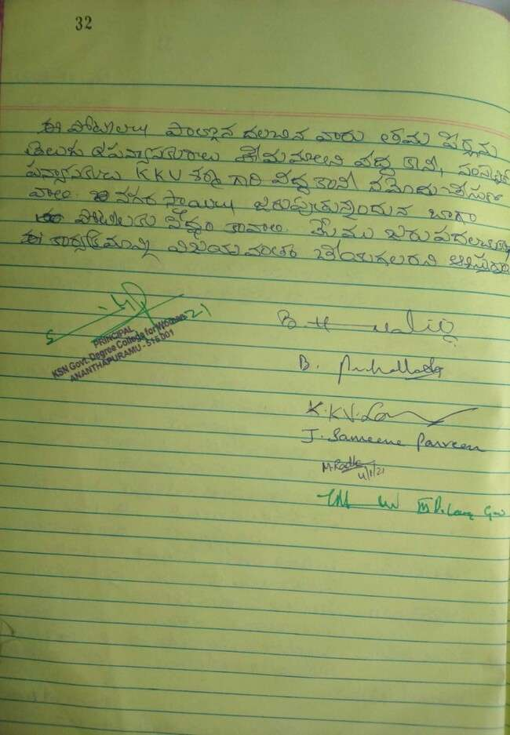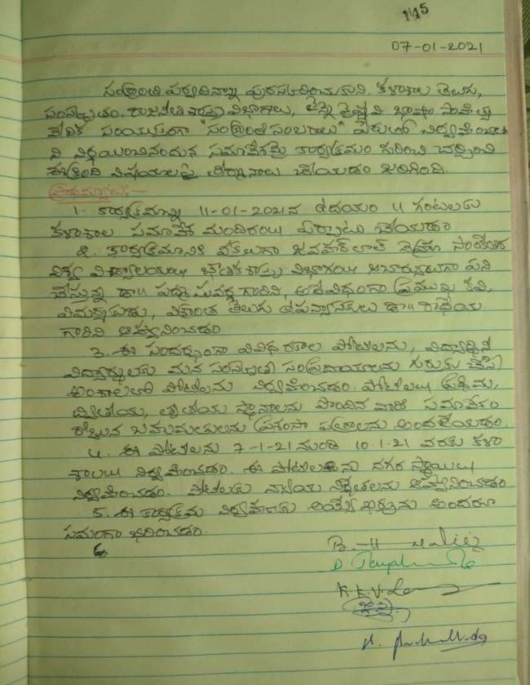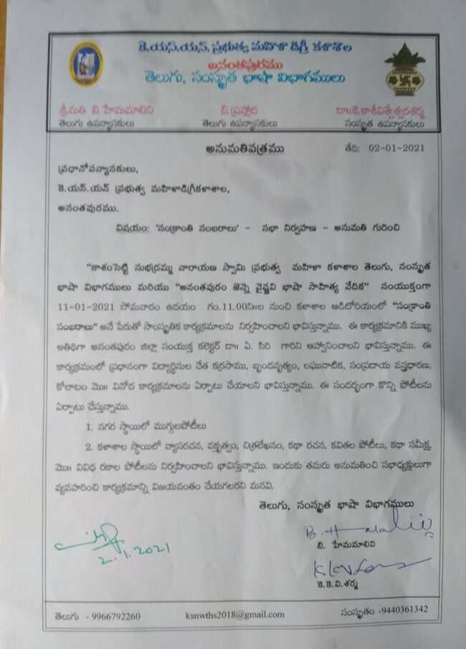

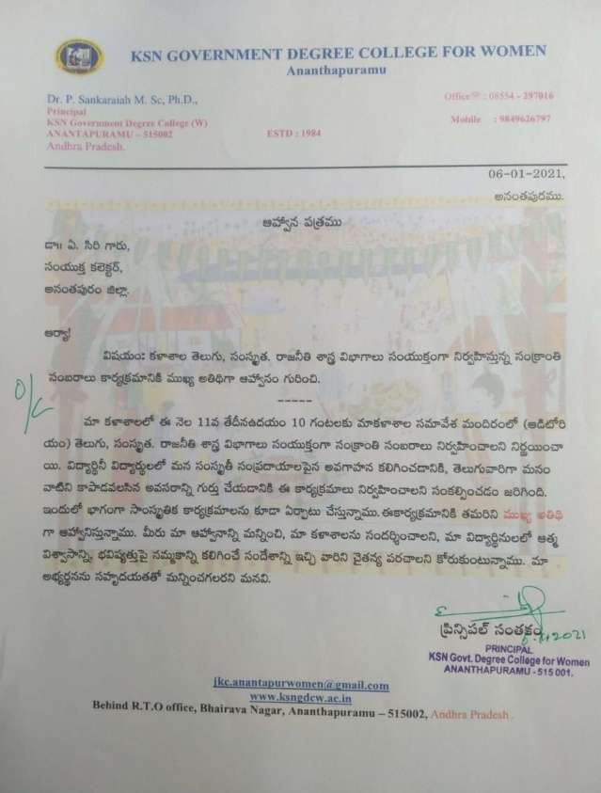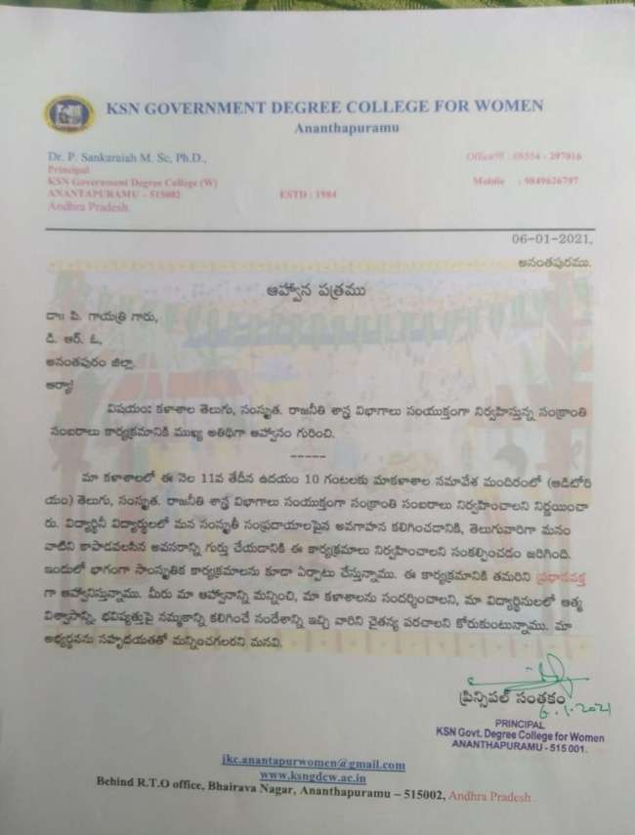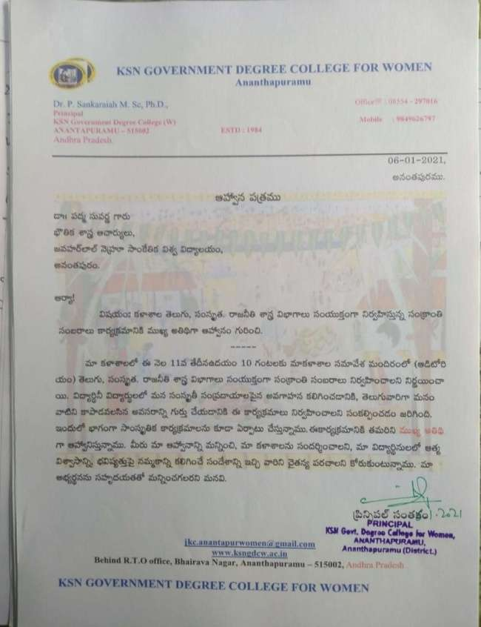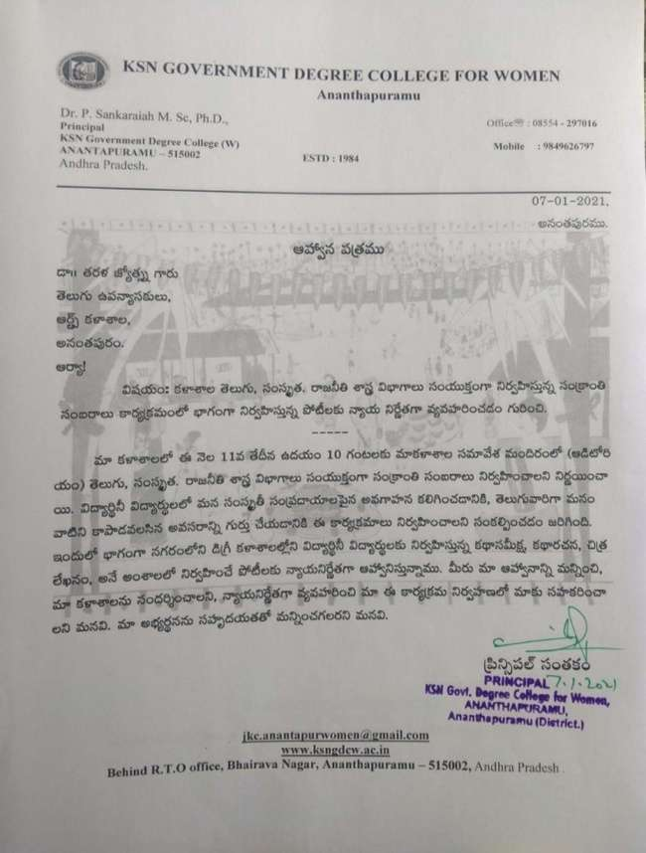

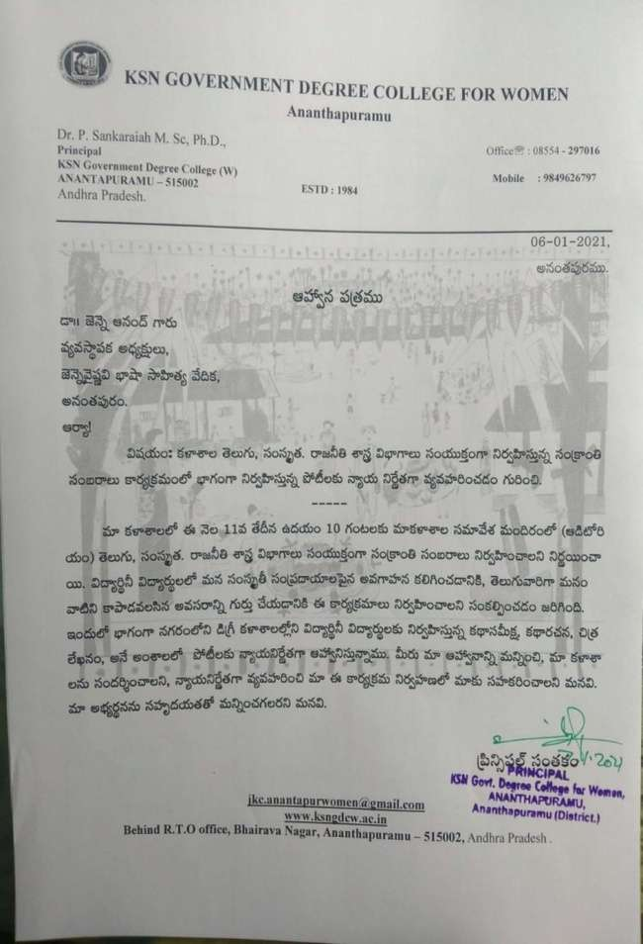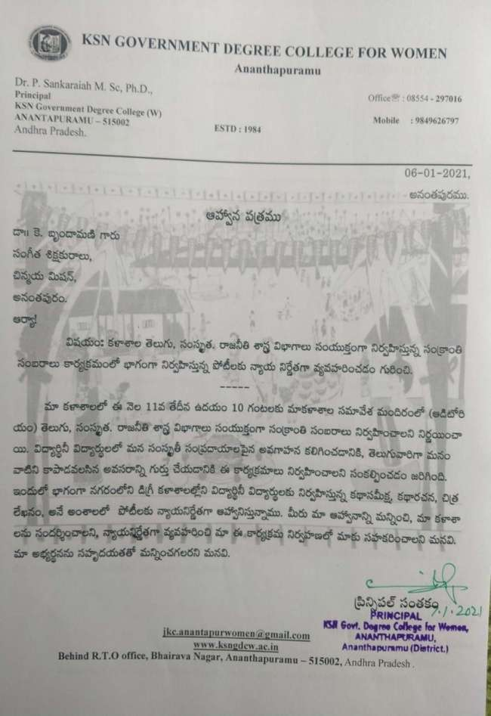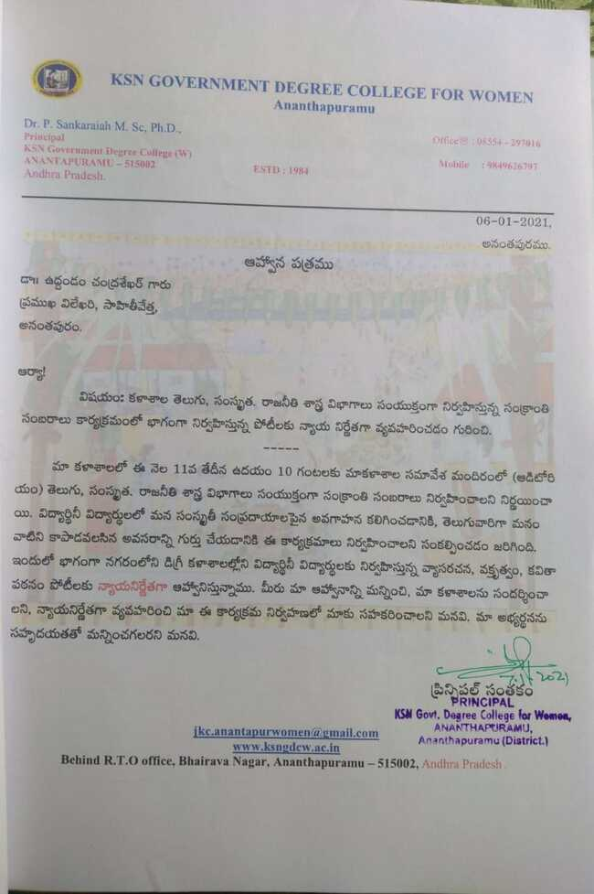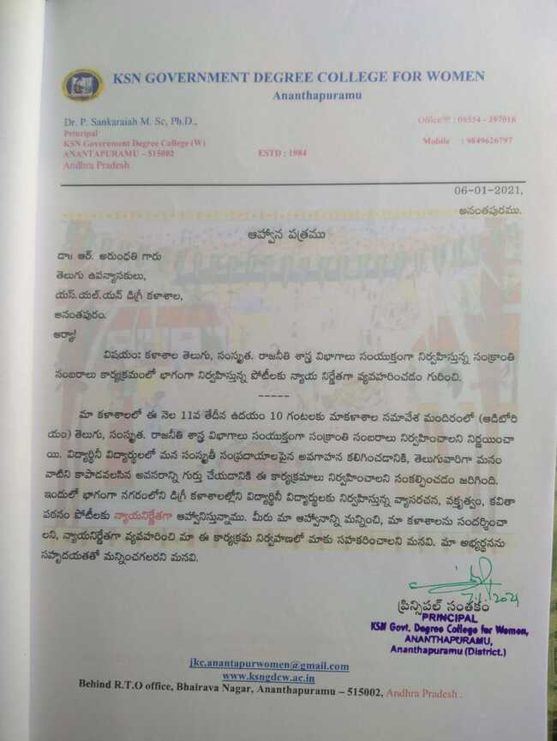

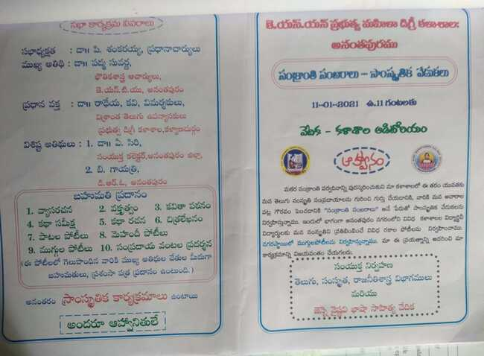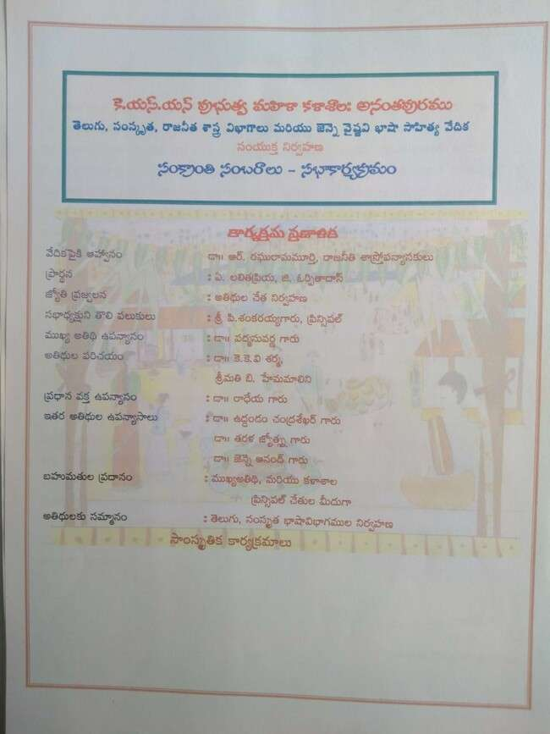

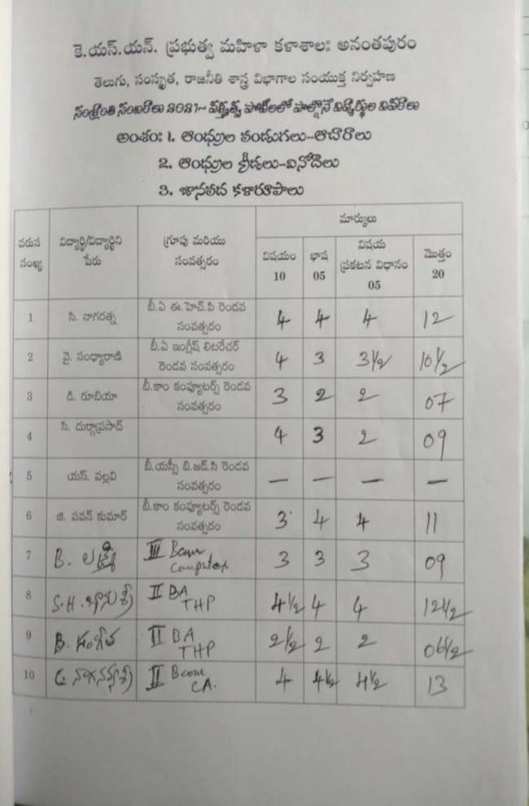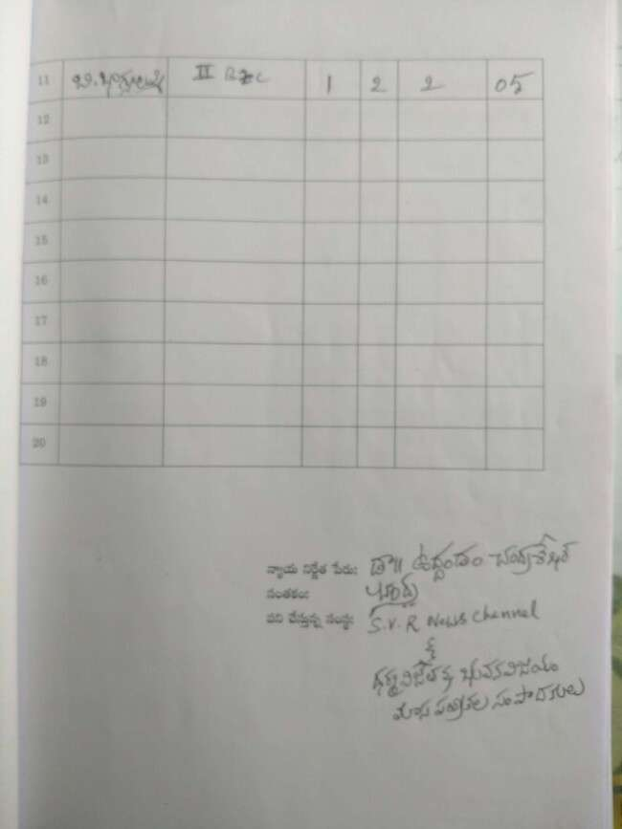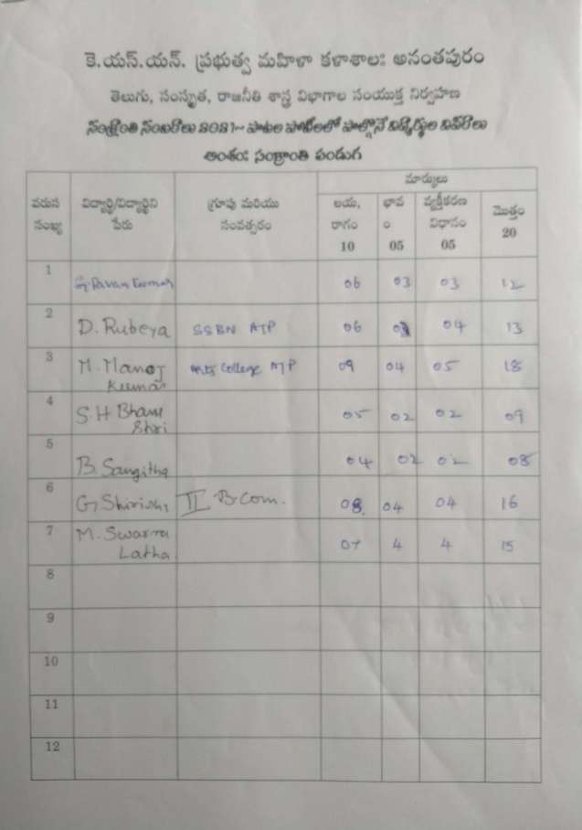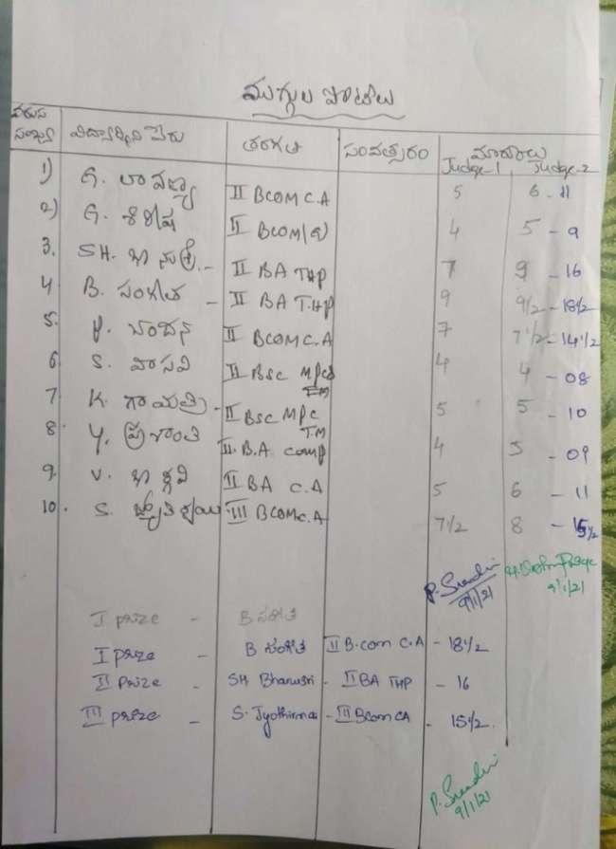

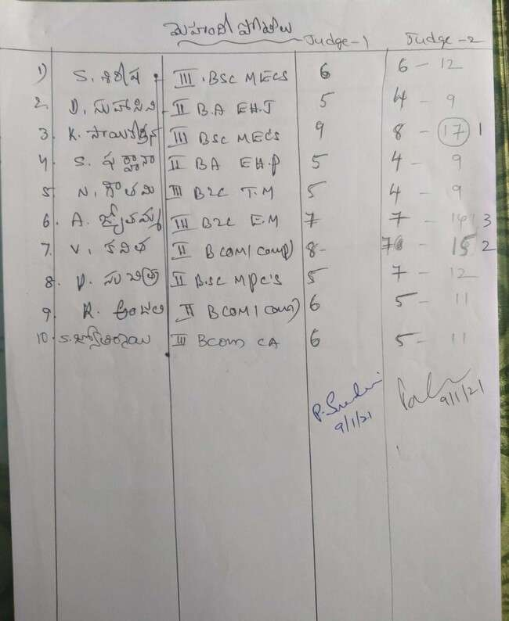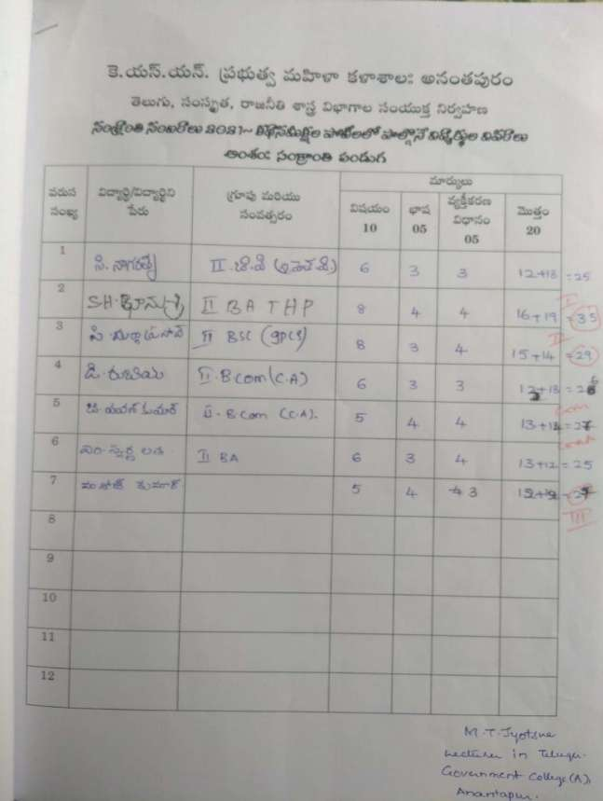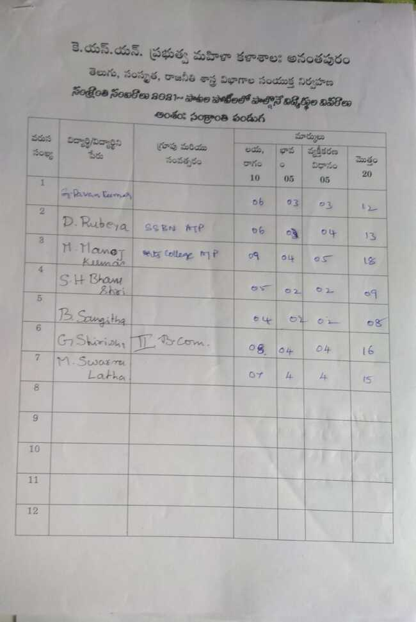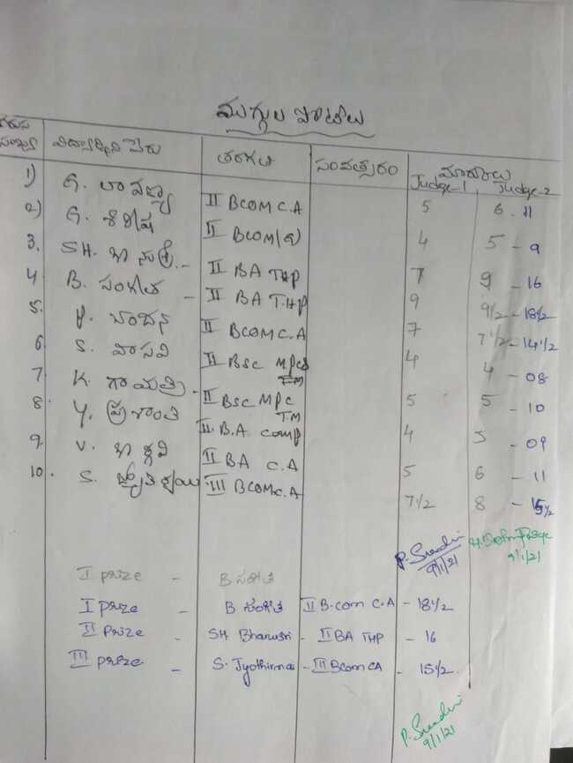

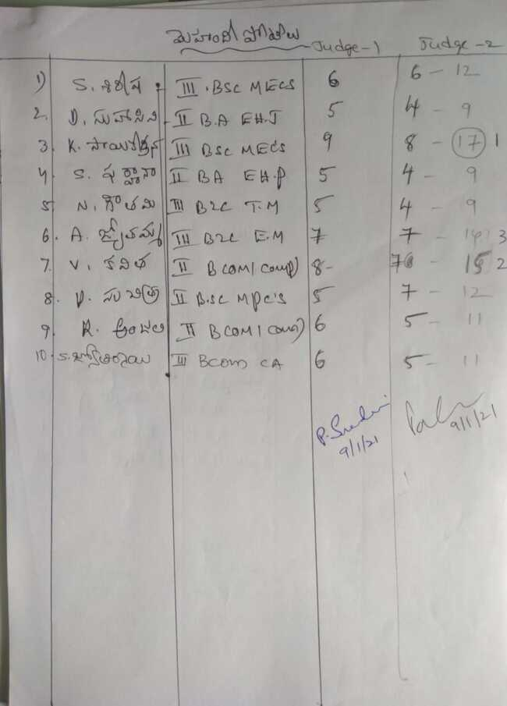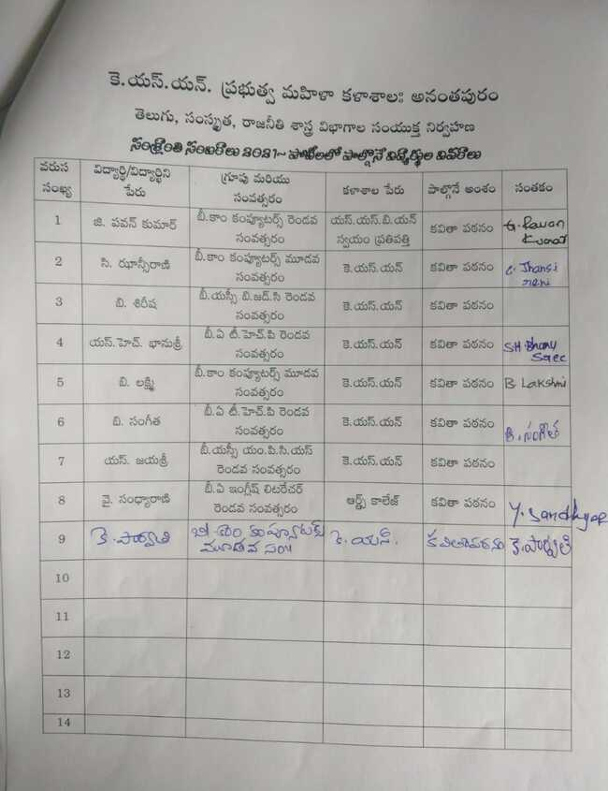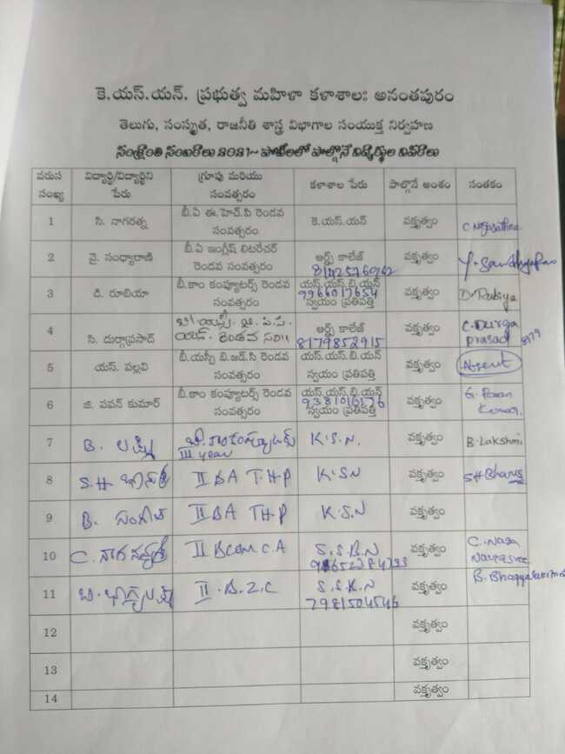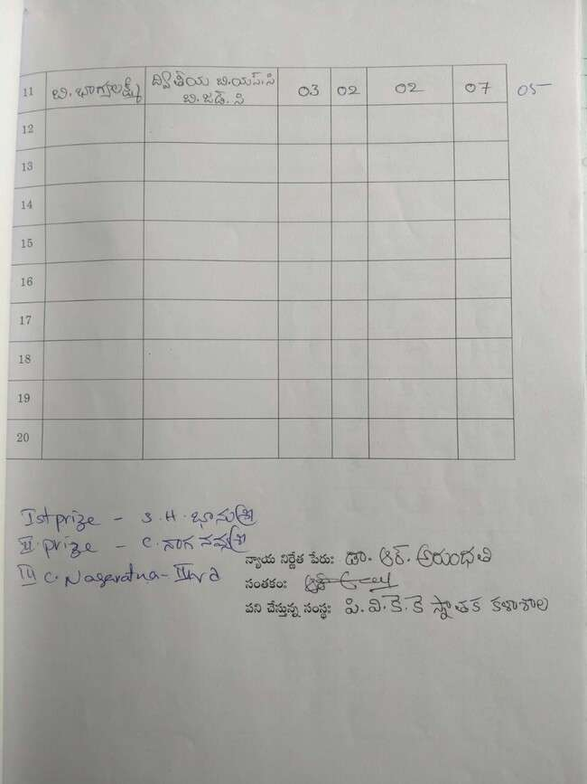

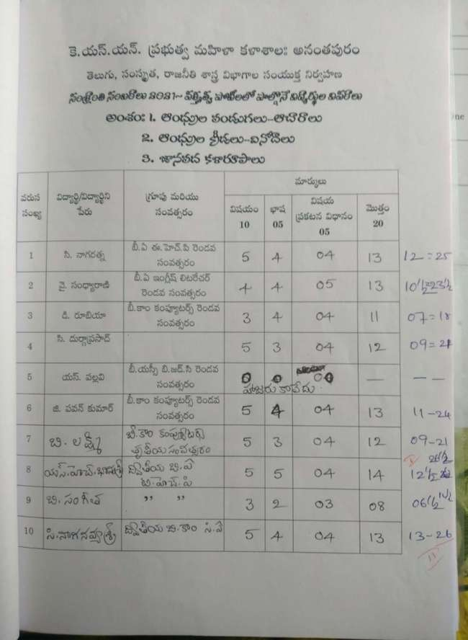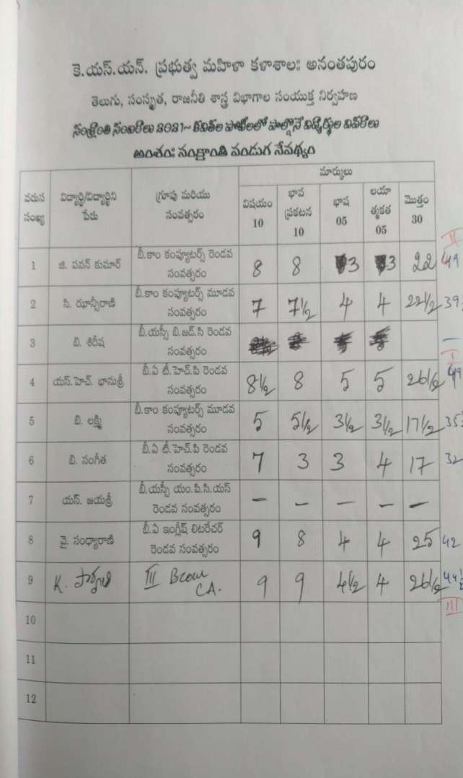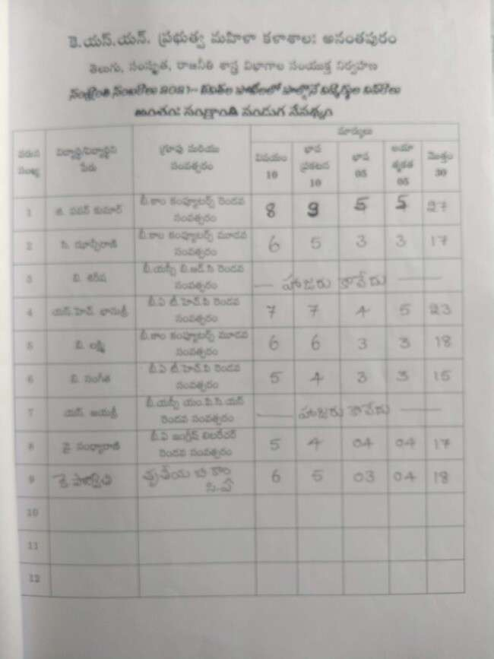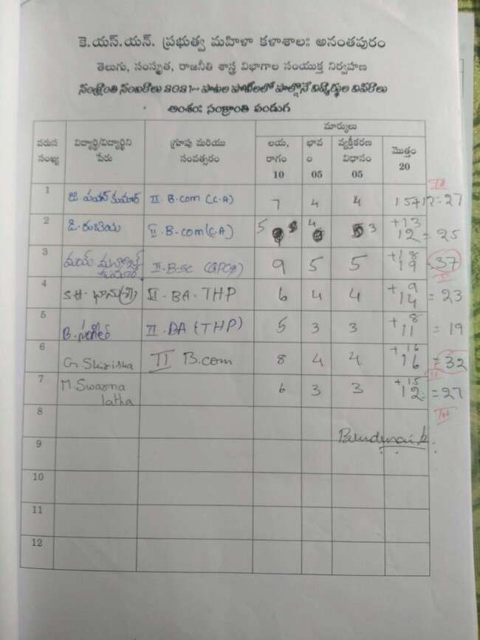

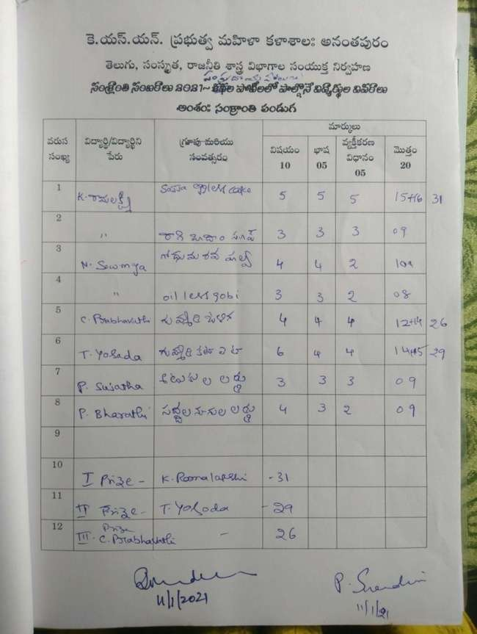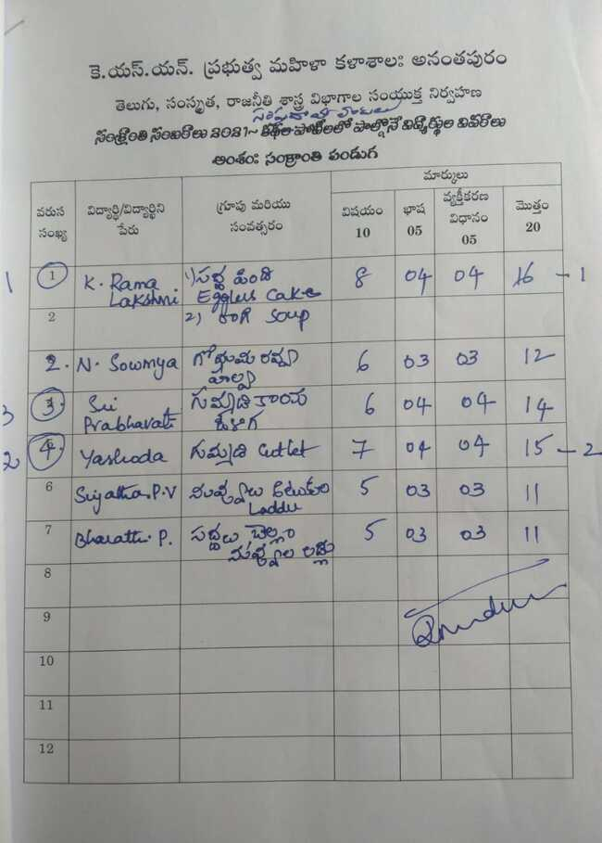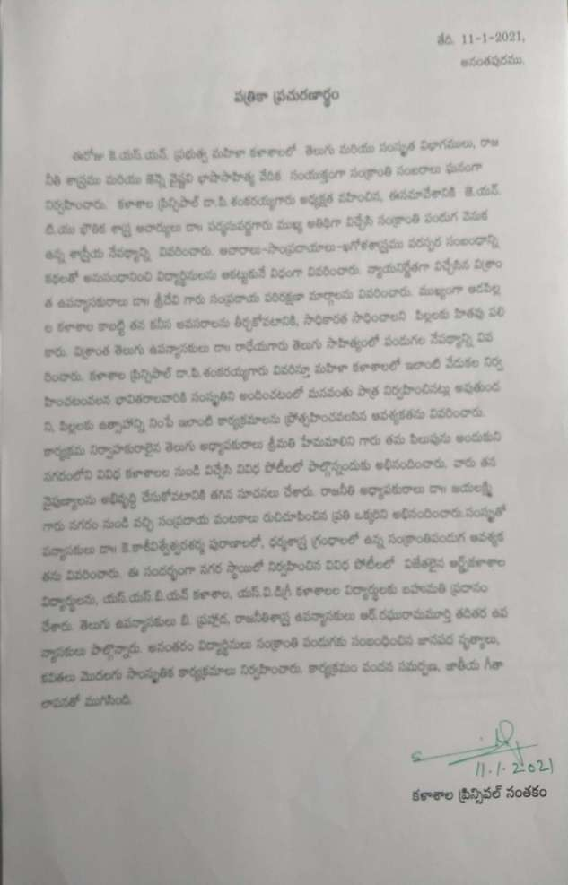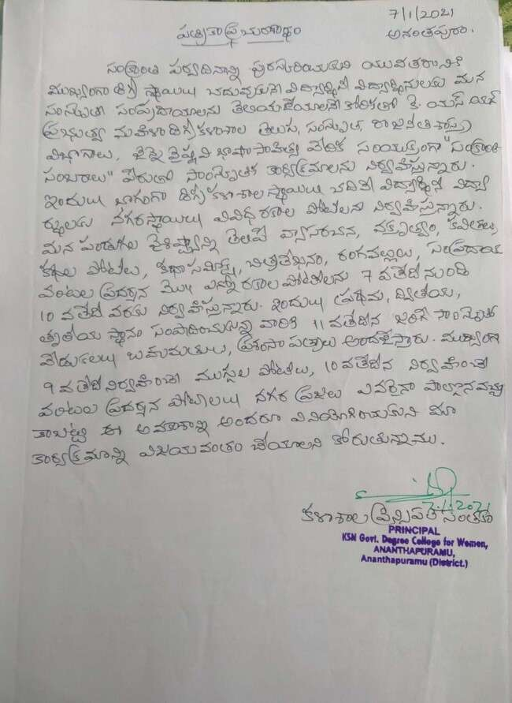

**Judges receiving invitation letters from the principal – Invitation to the judges by college staff – Meeting with dance masters regarding cultural events**

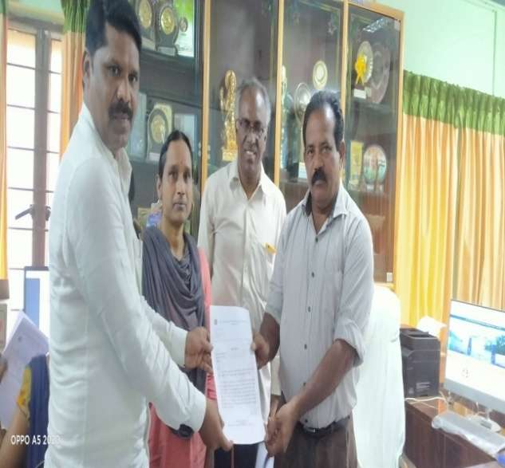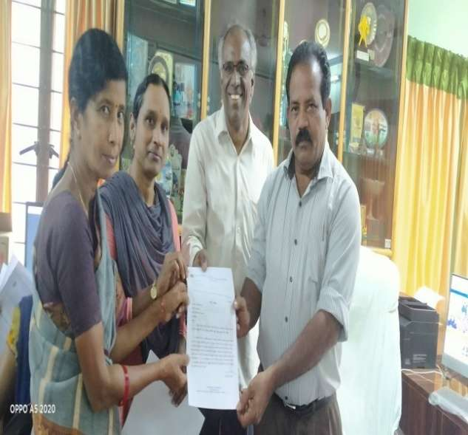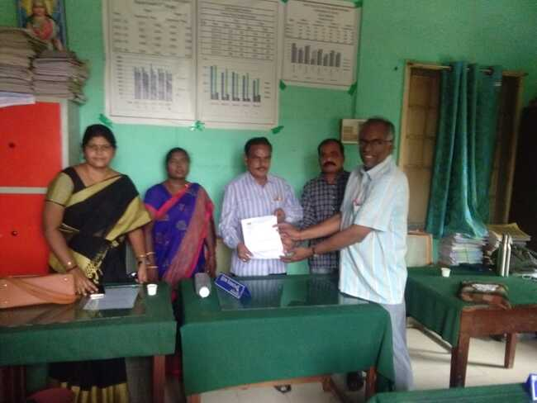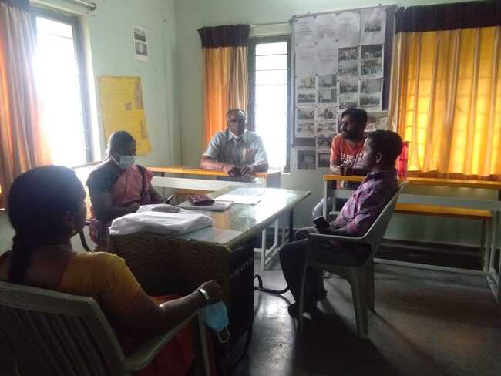

**Different Competitions were conducted for the students from all the degree colleges of Anantapur City. Essay Writing, Elocution, and poetry recitation competitions**

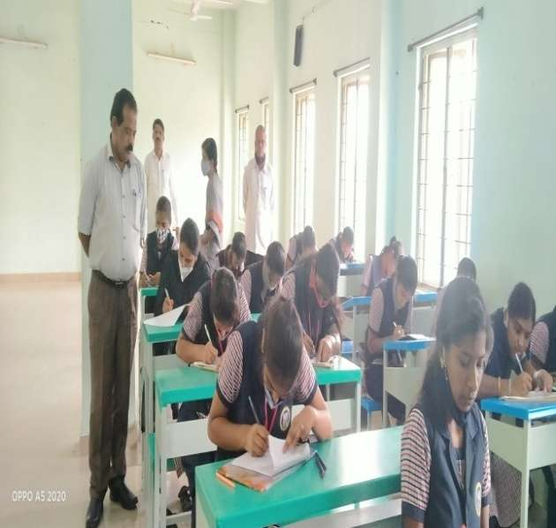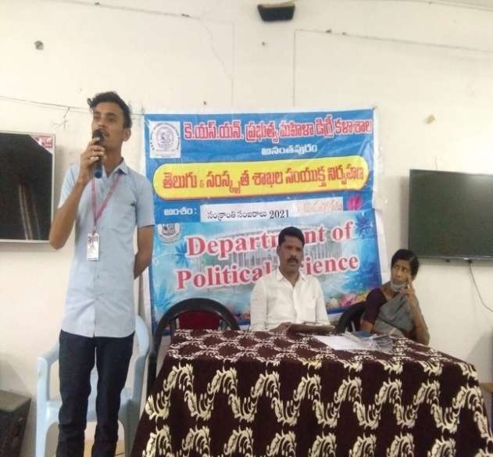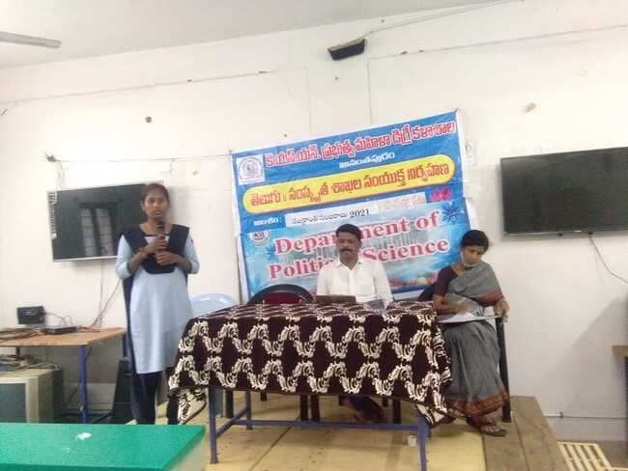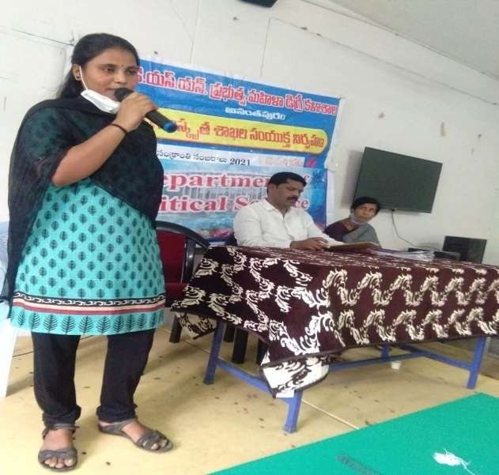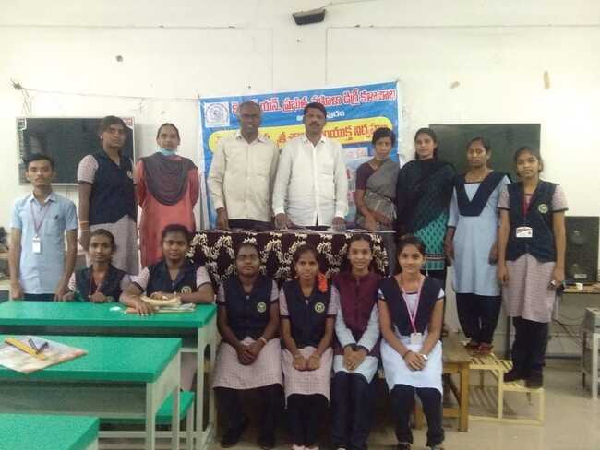

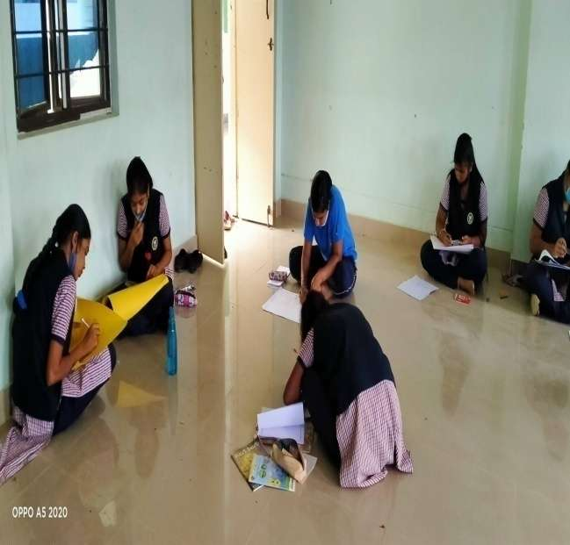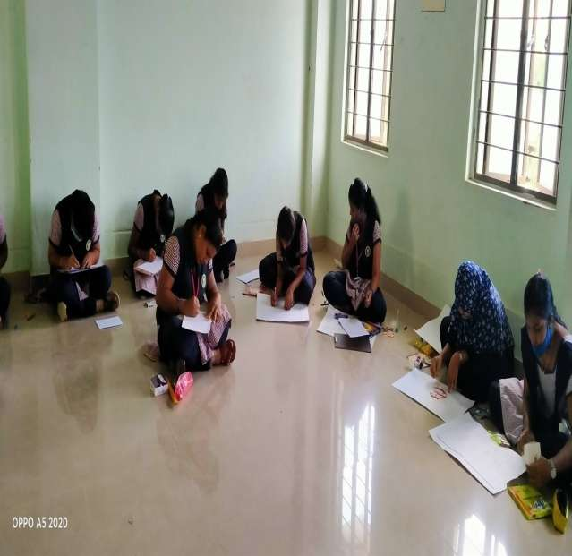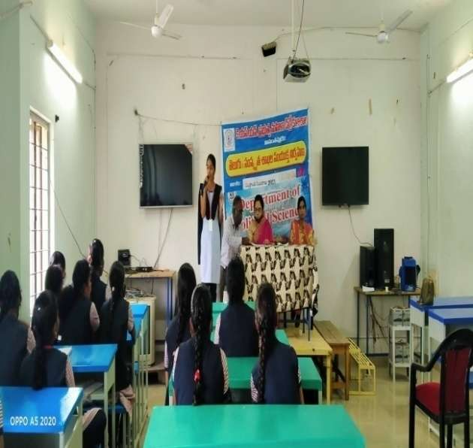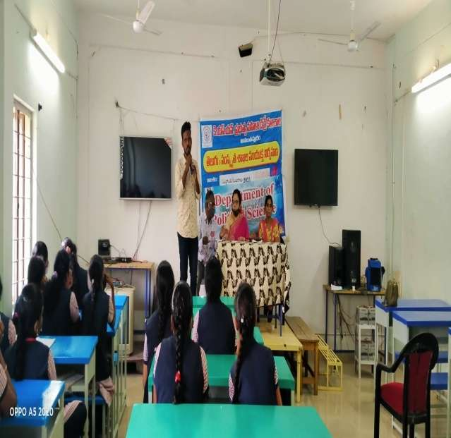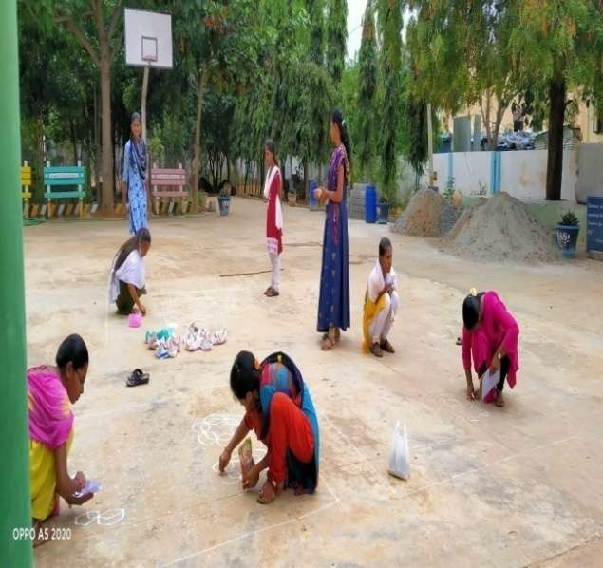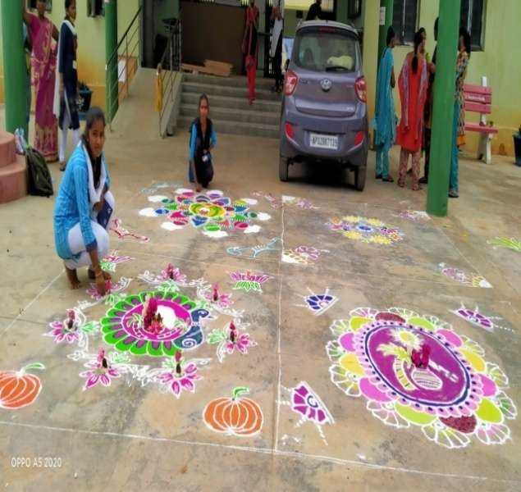

**Judges discussing about the winners – Mehandi Competitions – judges observing the competitions**

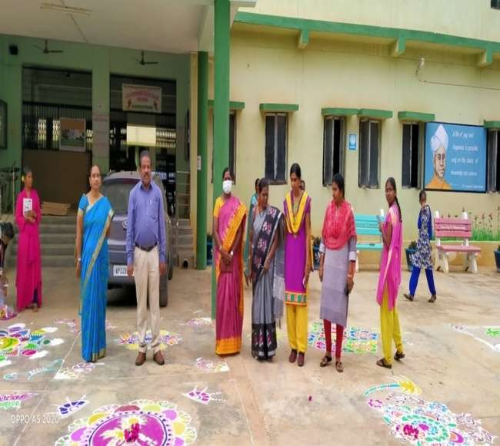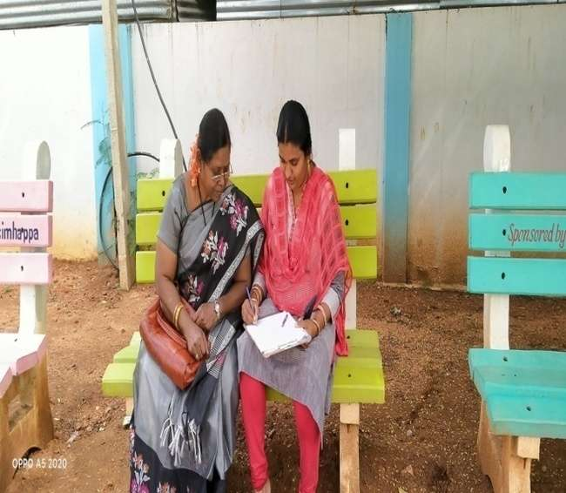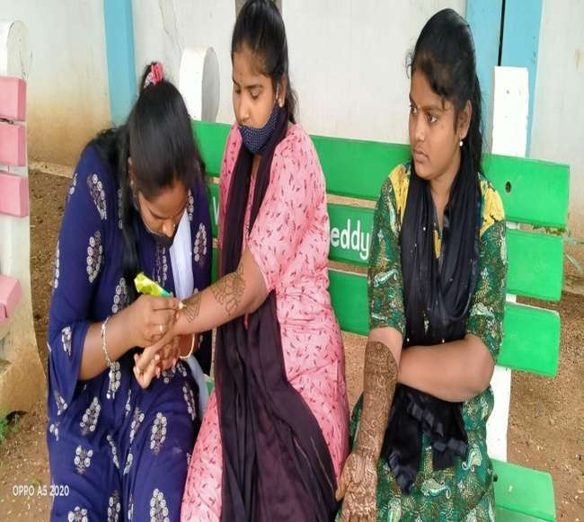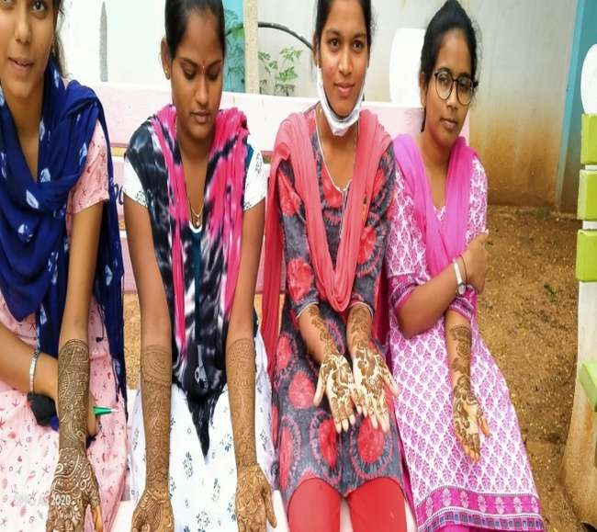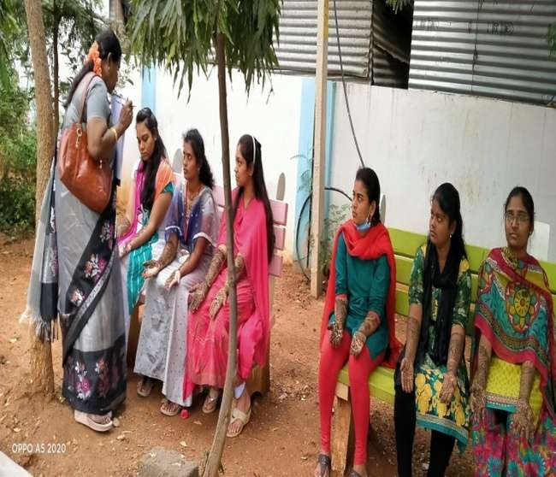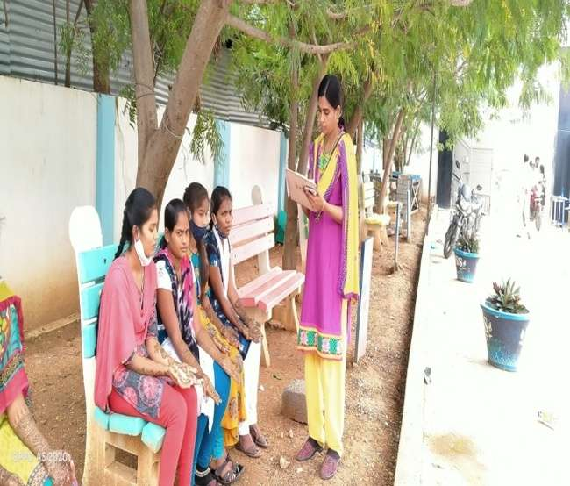

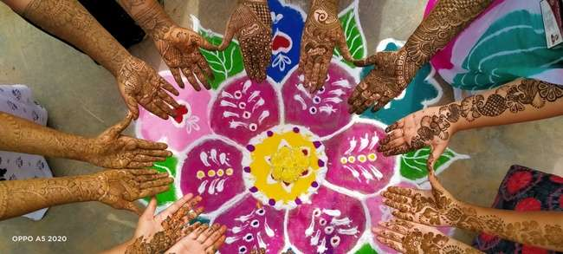

**Inauguration of the program by performing pooja – Students welcoming the guests**

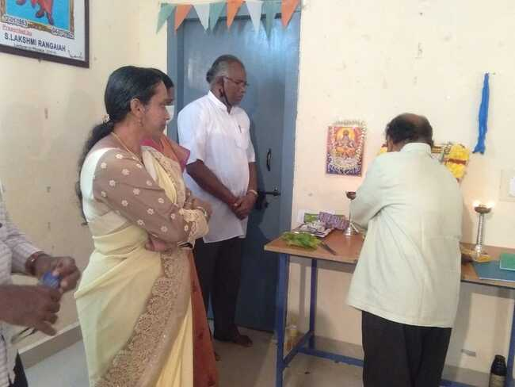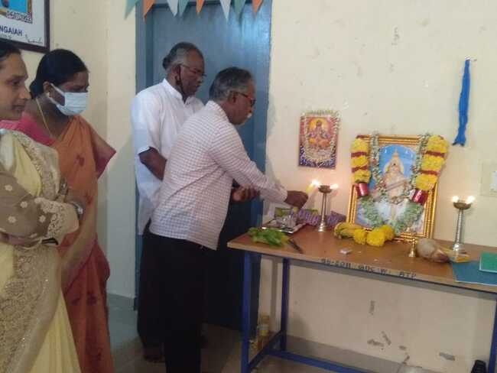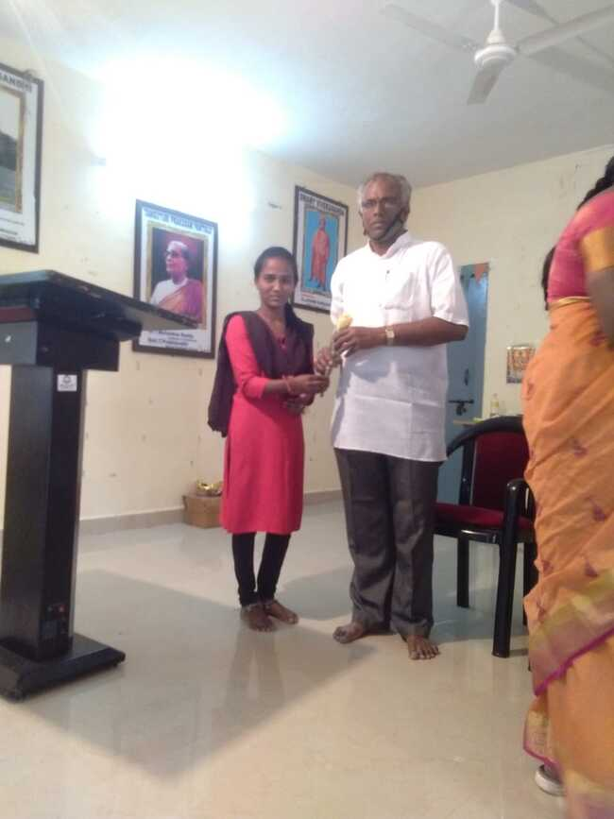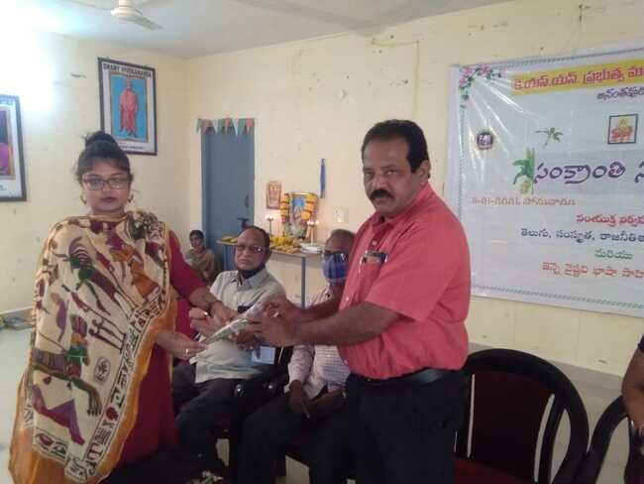

**Students welcoming the guests – Speech by the Chief Guest Dr. Padma Suvarna – Speech by Dr. JenneAnand, Co – Organizer of the program – Principal testing the food made by the competitors**

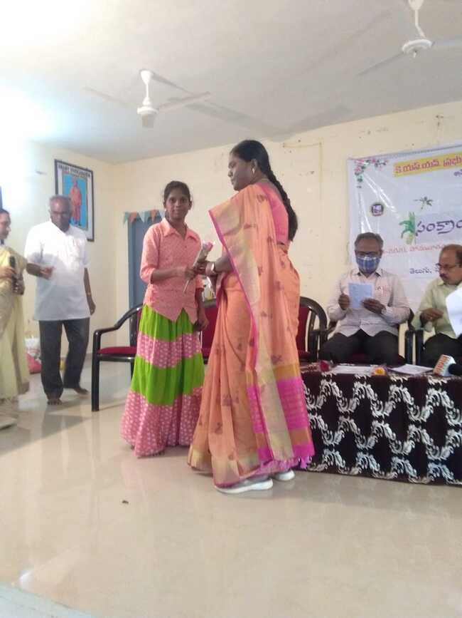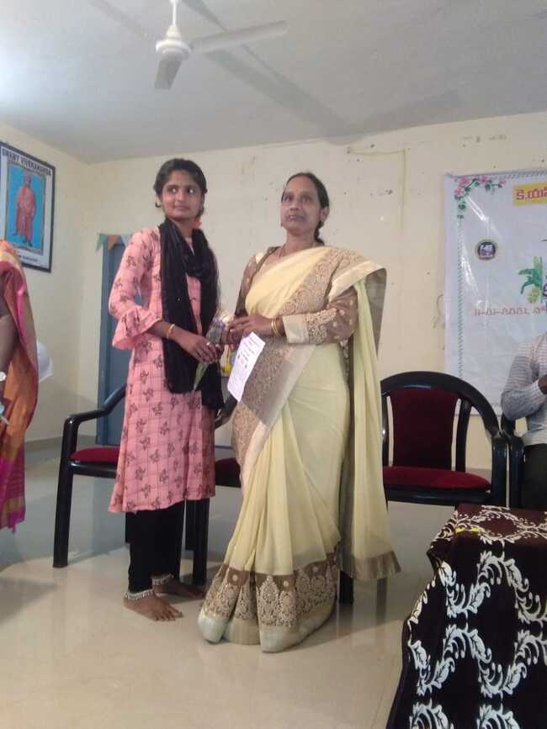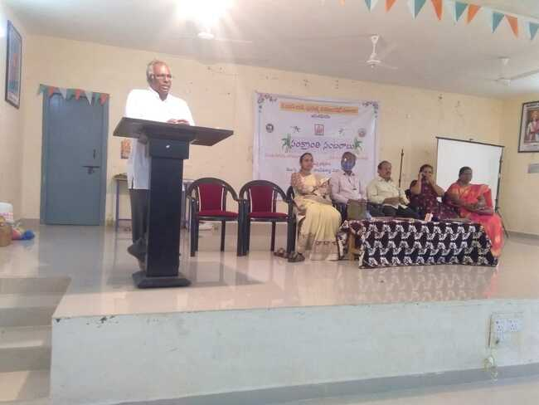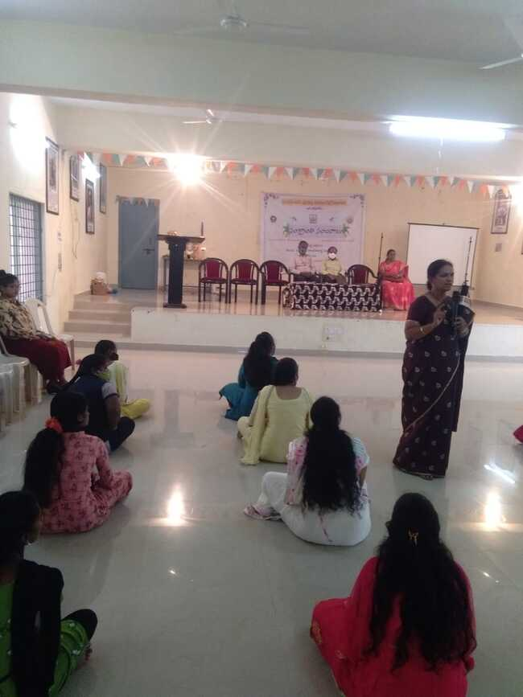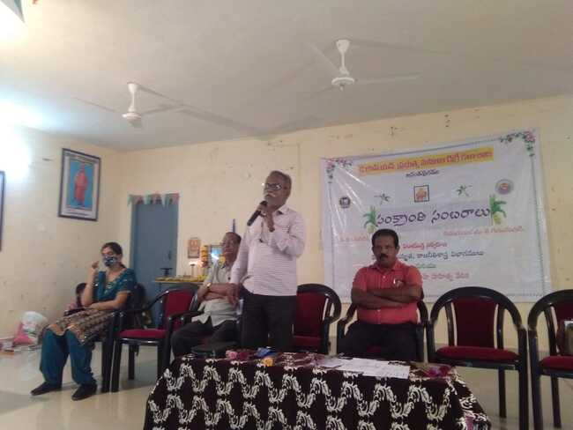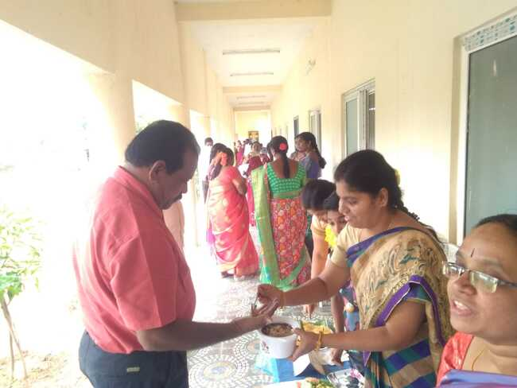

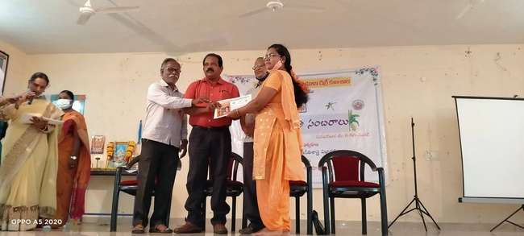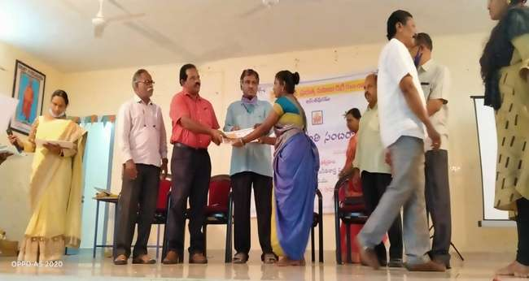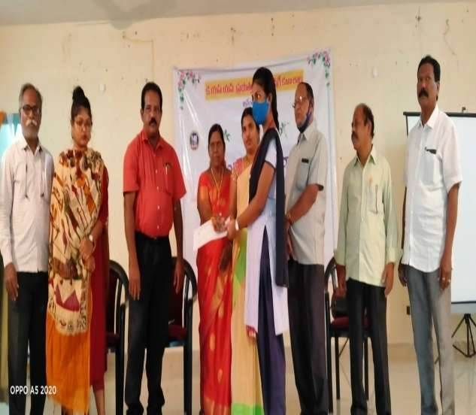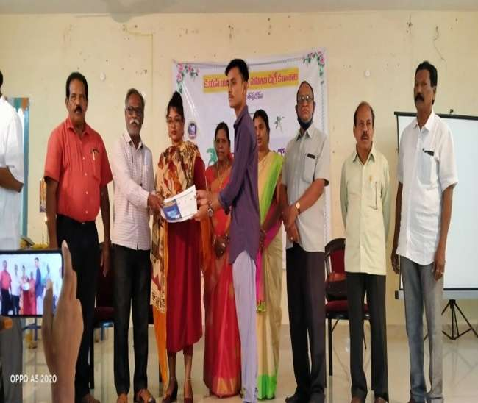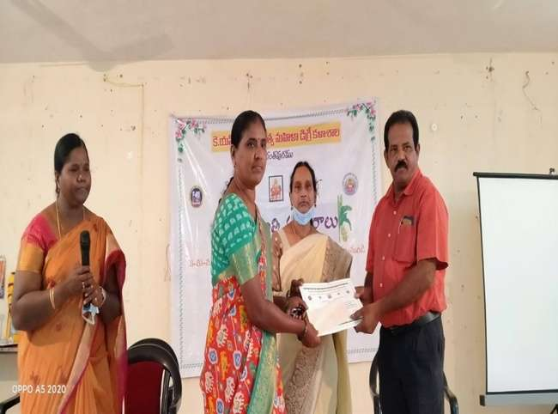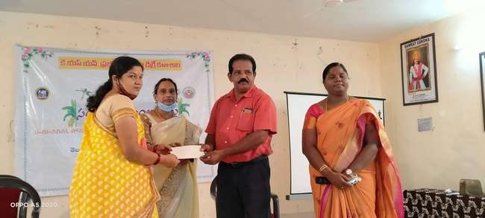

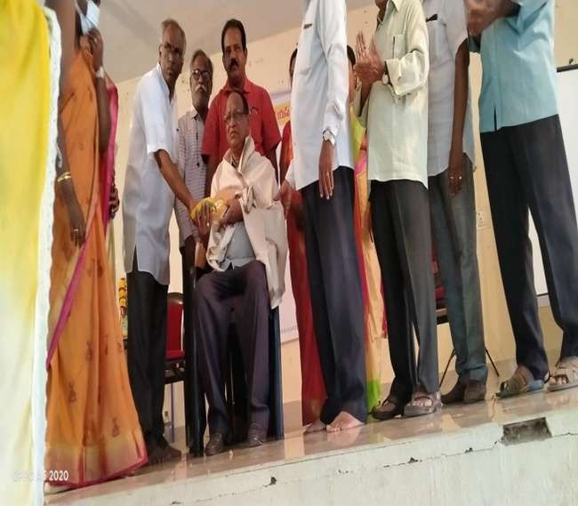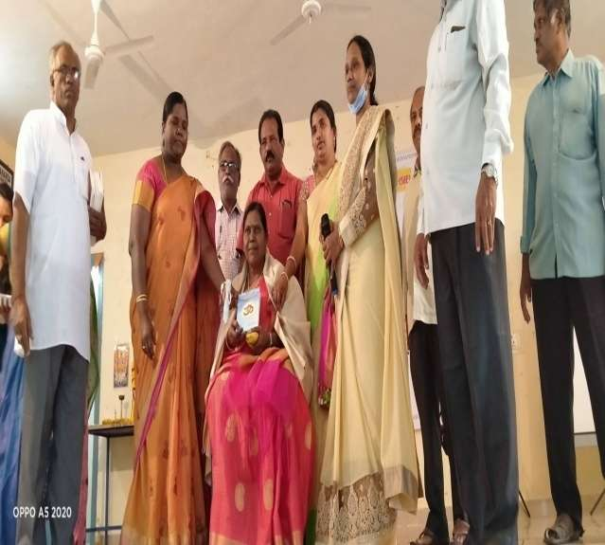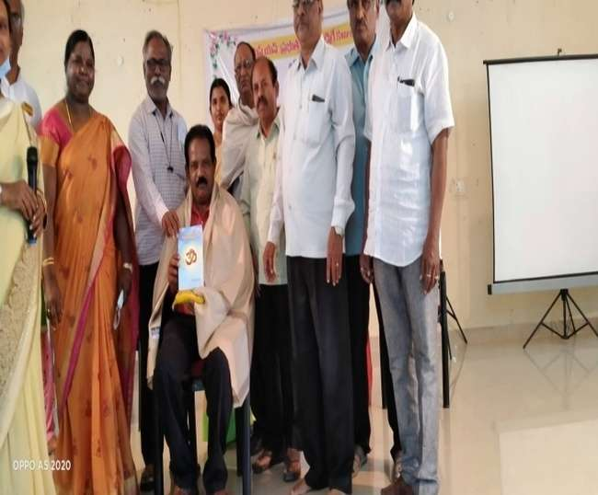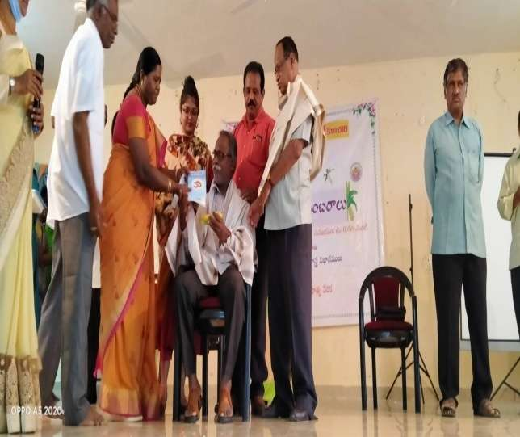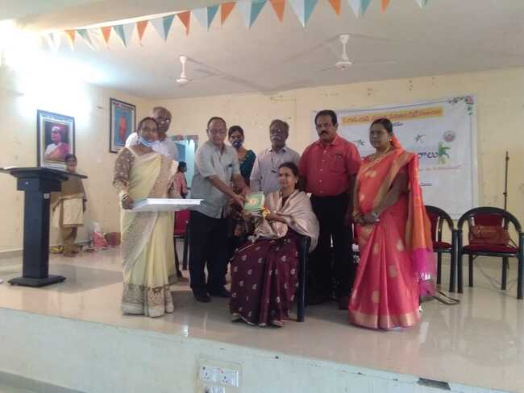

**Permission Letter from the Principal to conduct the program – Circular of the competitions – Circular of the program – Minutes of the program**

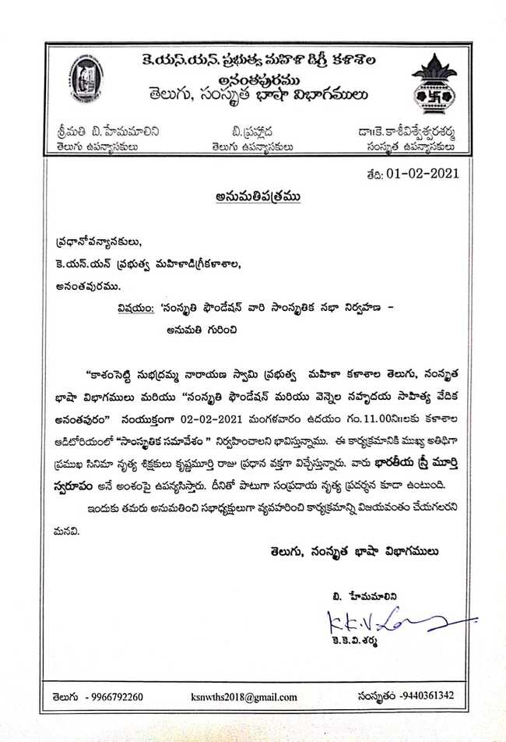

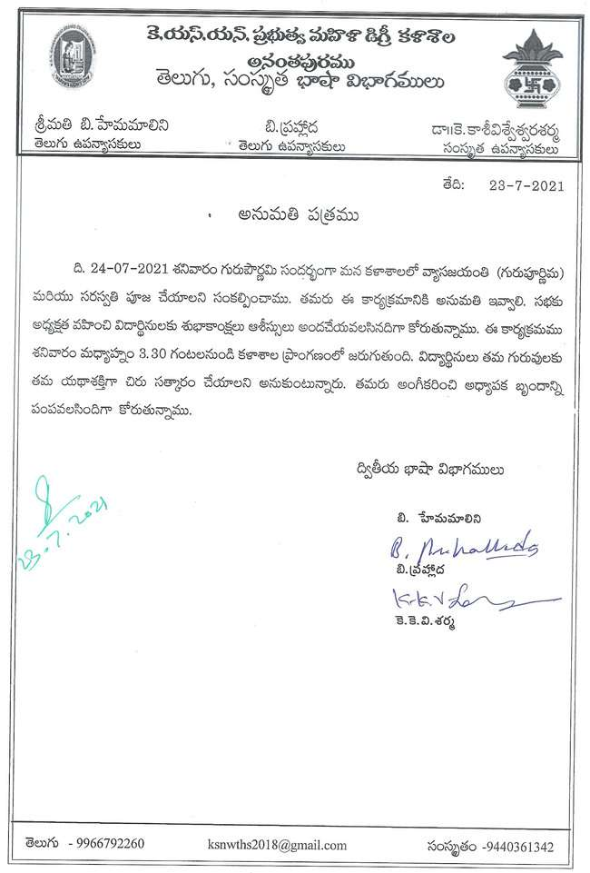

Bharateeya Sthree Murthi Swaroopam Program was organized second Languages and Samskriti Foundation and vennela Sahrudaya Sahithya vedica on 01—2-2021 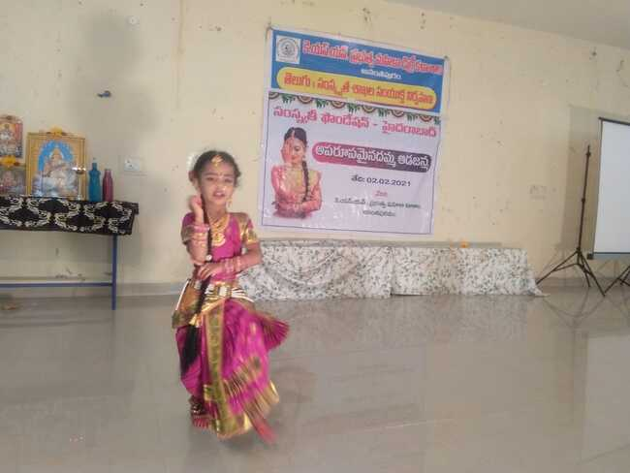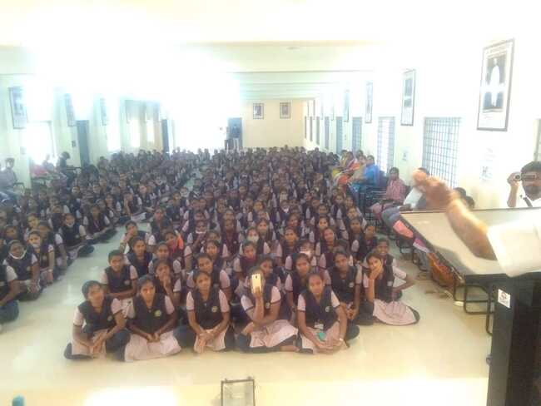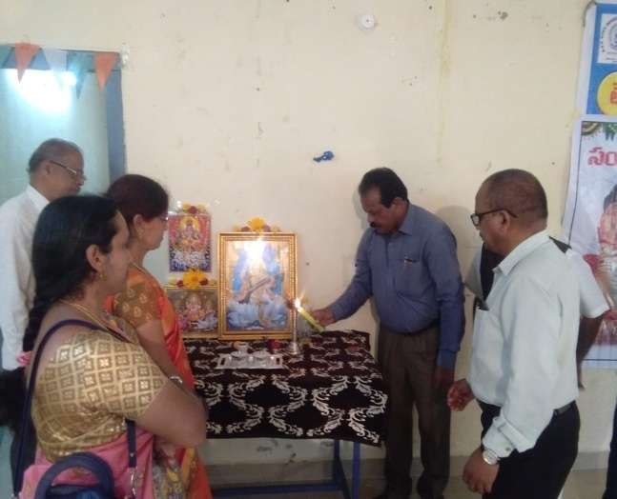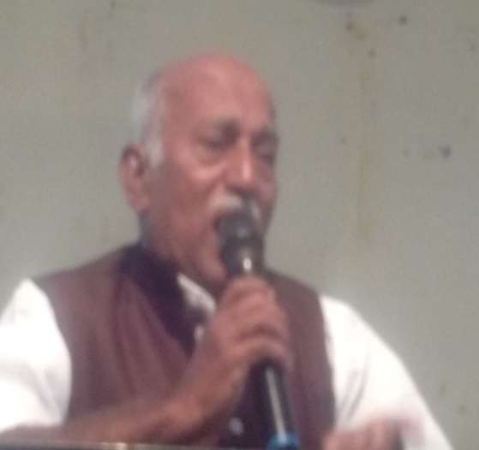

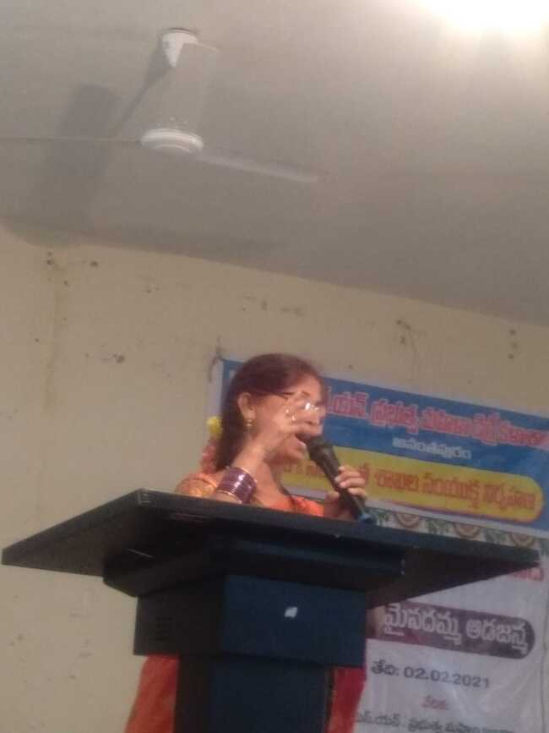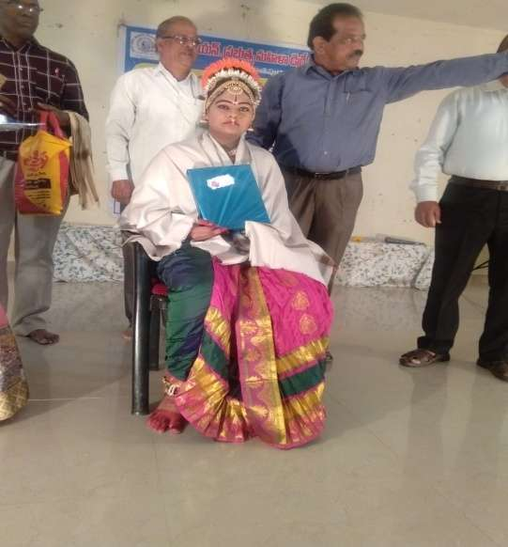

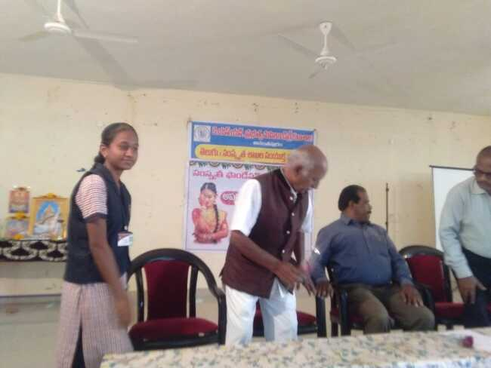

Krishnamurthi garu invited as Special Guest. Principal Dr.P. Sankariah

and Vice Principal Lakshmirangaiah.

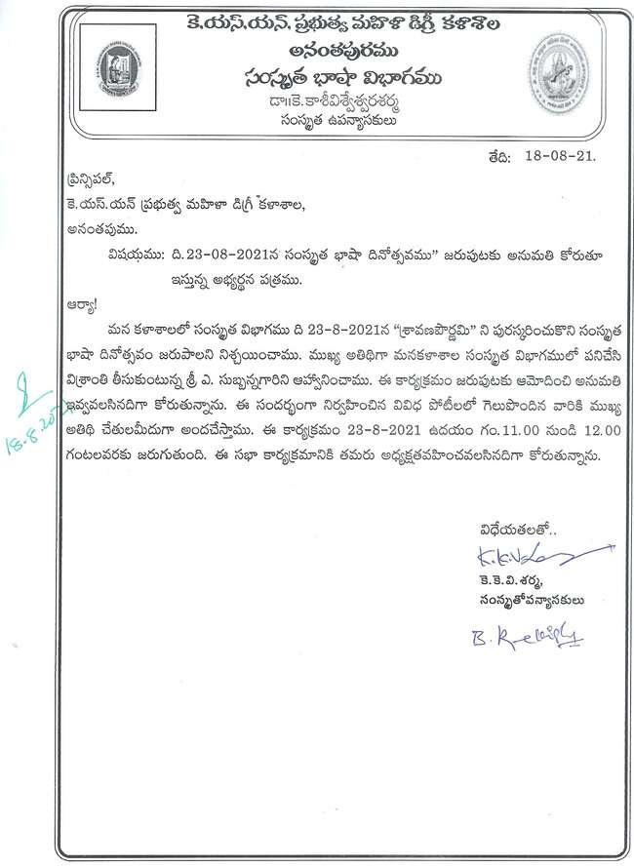

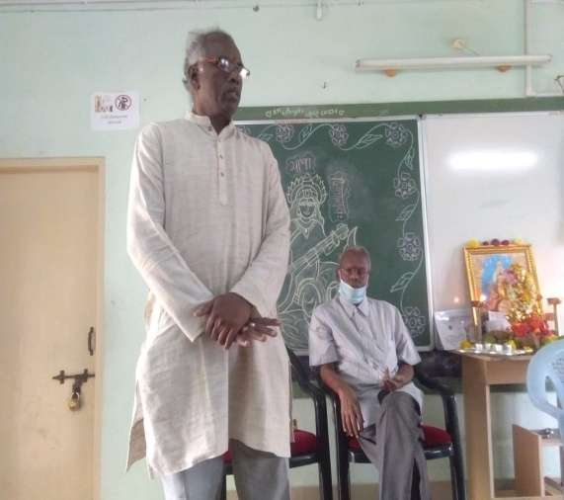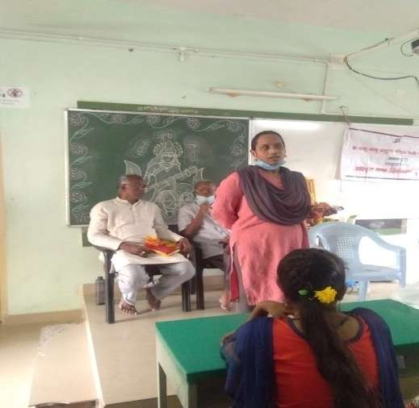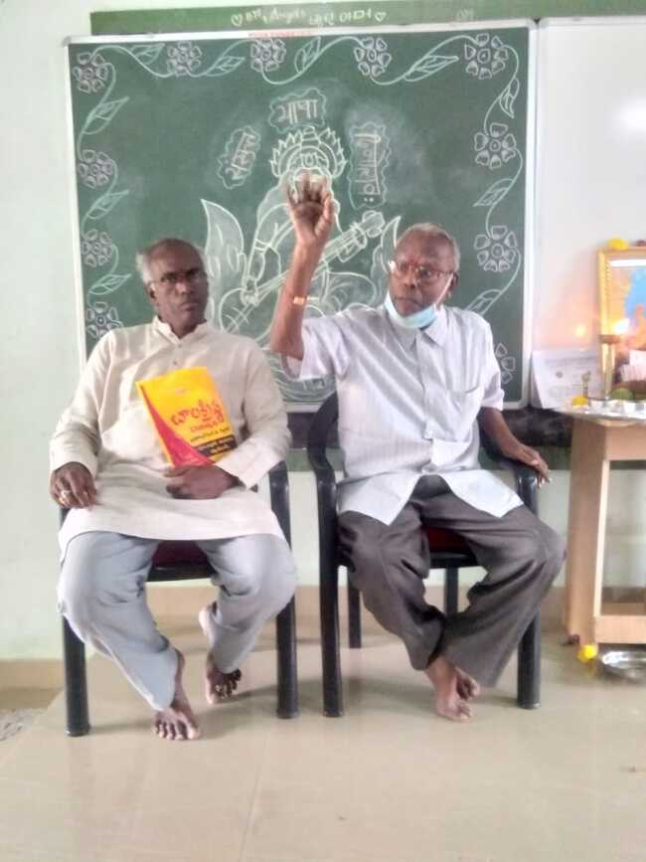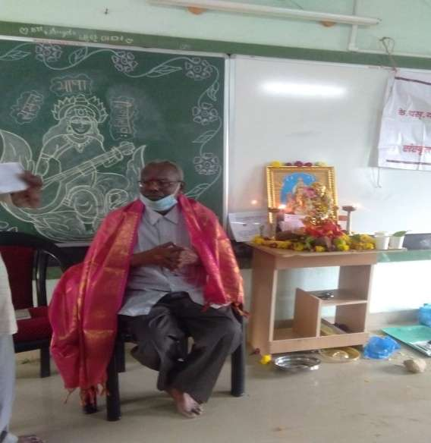

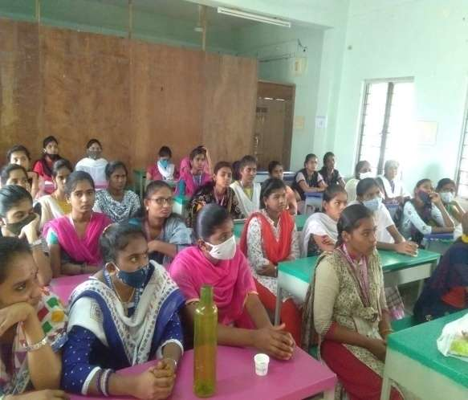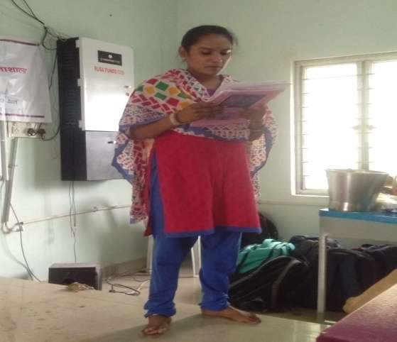

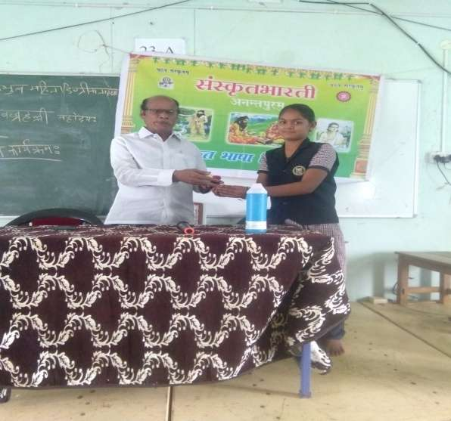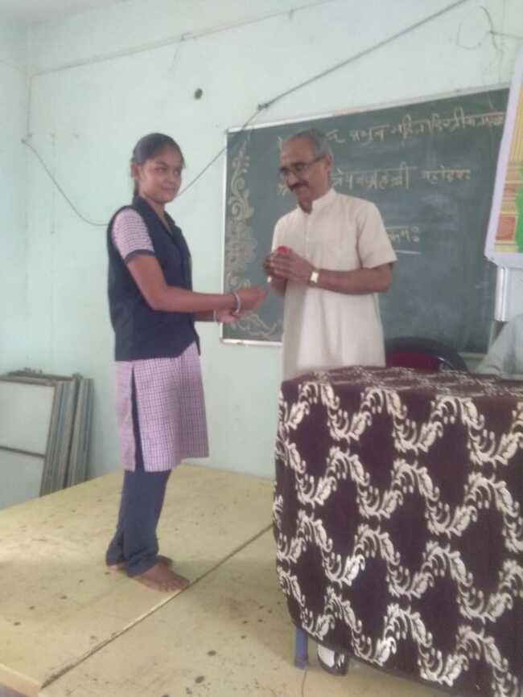

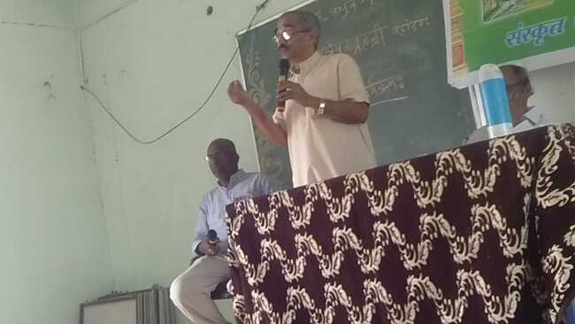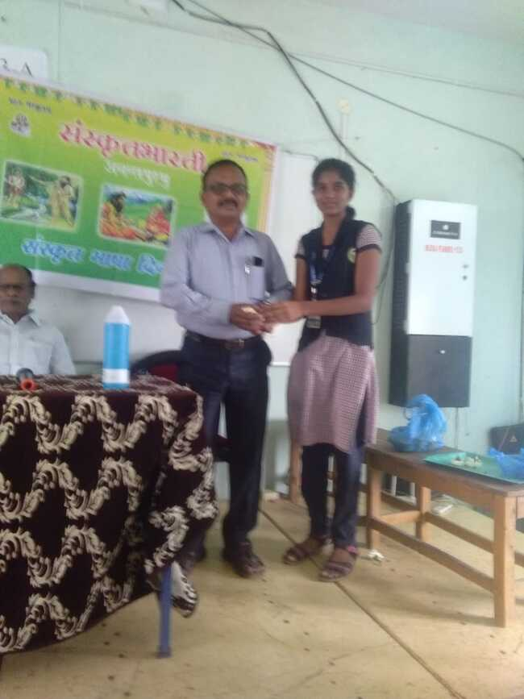

10-2-2021 Sri DattatrayaVajrahalli, Secretary, SamskritaBharati (Karnataka, Andhra &Tamilnadu

And Dr.P.P.V.D. Naga Trisulapani Rtd Principal and H.O.D of Sanskrit in S.S.B.N Degree College, Anantapur. He is also Anatapur District President Samskrita Bharati

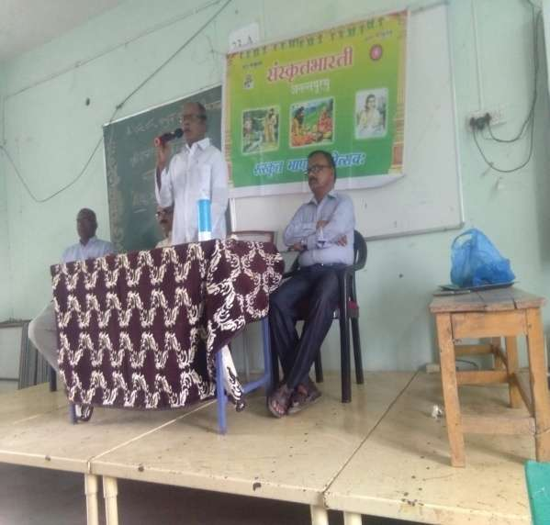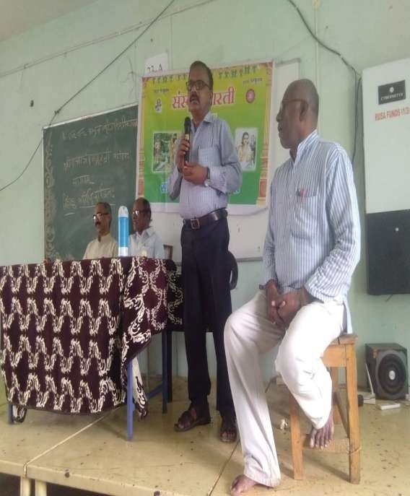

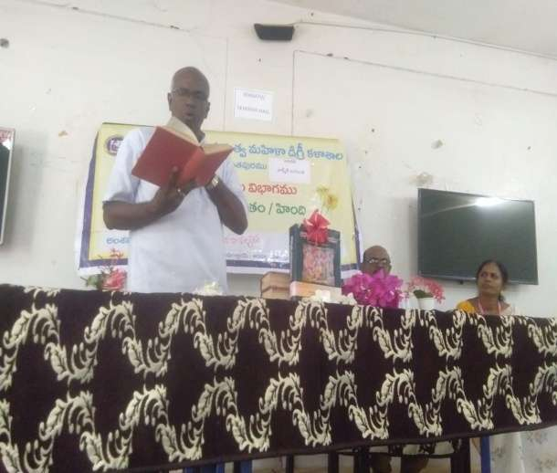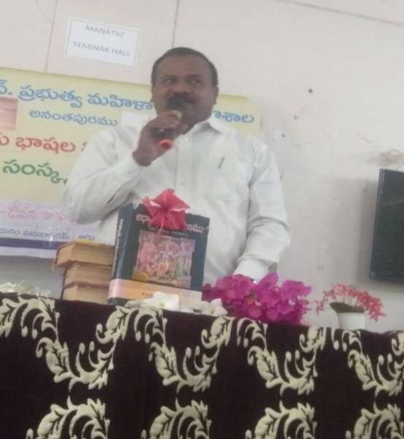

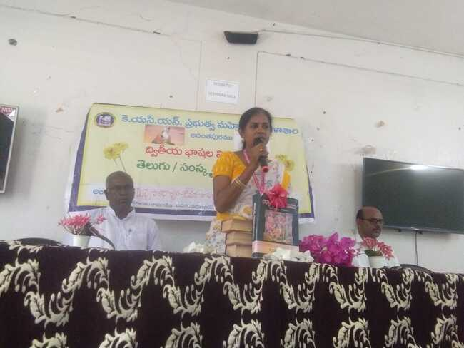

AdiKaviValmikiJayanthi Conducted by Telugu, Hindi & Sanskrit 22-10-2021

DrRamanjaneyulgu, Lecturer in Political Science - Chief Guest of Function

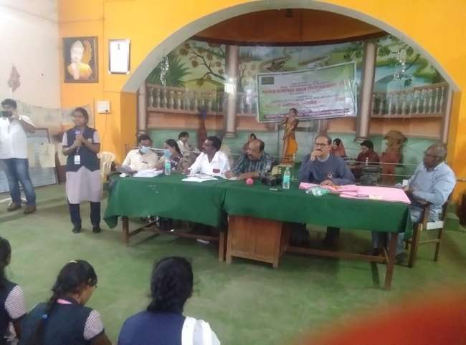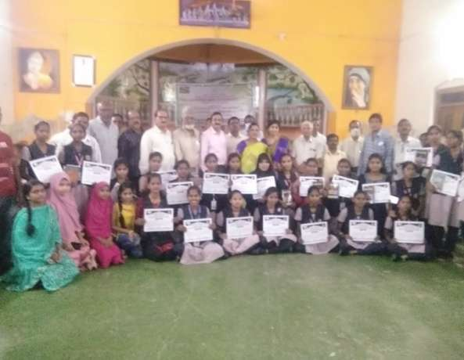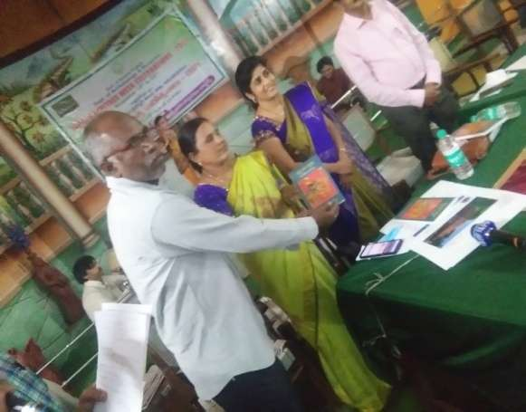

World Heritage Week Celebrations conducted by Department of Culture and Heritage on 18th to 25th November 2021. Nearly our College students 24 members are participated in elocution and essay writing competitions and get 2nd and 3rd prizes. Dr. K.K.V.Sarma has motivated students and he is one of the guest in this function.

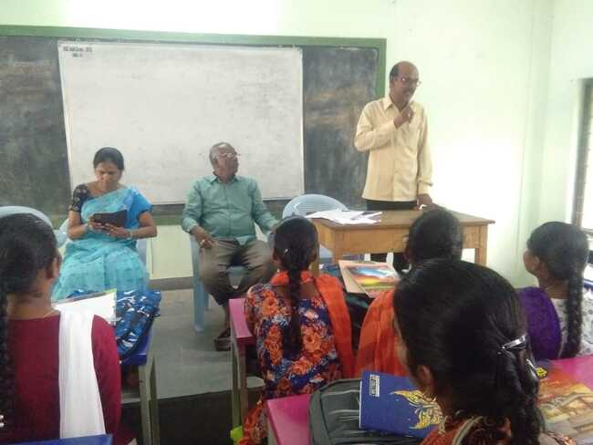

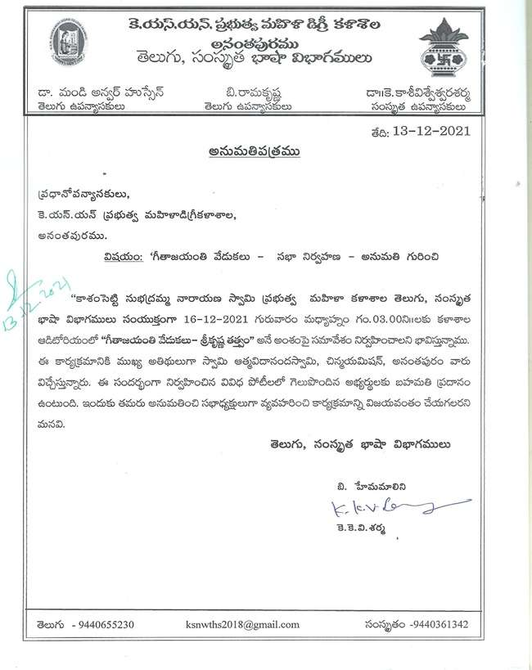

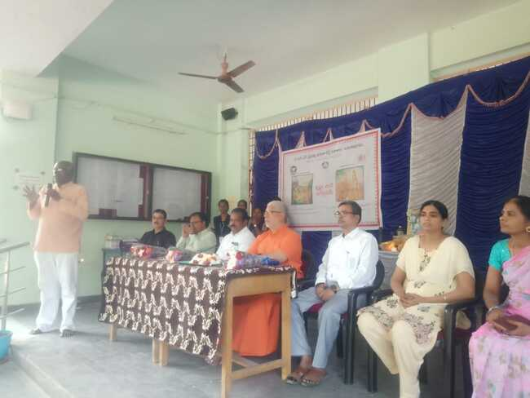

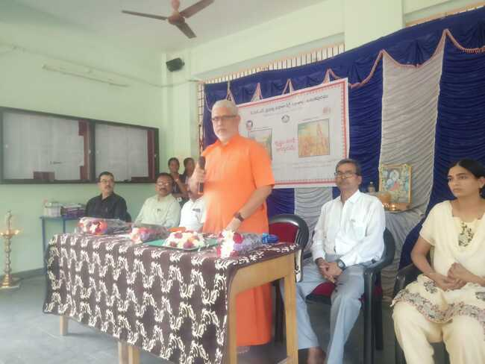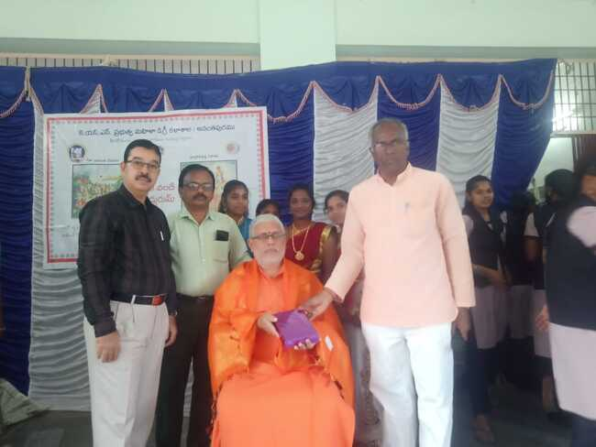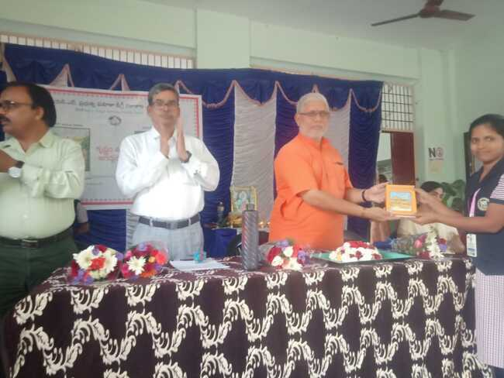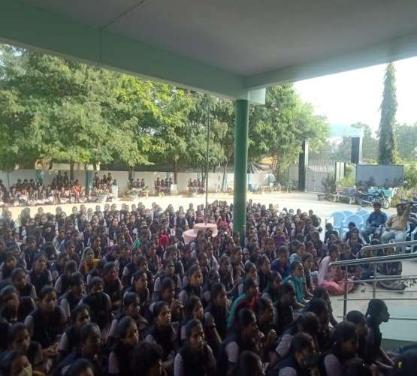

**K.S.N.GOVT.DEGREE COLLEGE, ANANTAPUR**

**Departments of 2nd Languages(Telugu, Sanskrit & Hindi**

**GEETHA JAYANTHI COMPITIONS 2021 DECEMBER**

|  |  |  |  |  |
| --- | --- | --- | --- | --- |
|  | **Name of the Competition** | | **Name of the Student** | **Year & Group** |
| Team-1 | QUIZ | | K.HARIKA | BZC |
|  |  | | G.DEEPTHI SAI | BZC |
|  |  | | B.PRIYANKA | MPCs |
|  |  | | V.DIVYA | MICRO BIOLOGY |
|  |  | | P.BHAVANI | PARAMEDICAL |
| Team-2 |  | | A.PURNASREE VYSHNAVI |  |
|  |  | | M.MONIKA |  |
|  |  | | V.GANGA RAJESHWARI |  |
|  |  | | V.APARNA |  |
|  |  | | P.CHAYTANYA |  |
|  |  | |  |  |
| Team-3 |  | | L.SIVA KEERTANA | MECs |
|  |  | | B.SASIKALA | MPCs |
|  |  | | C.SNEHITHA | MPCs |
|  |  | | M.VENKATALAKSHMI | MSCs |
|  |  | | A.HEMA LATHA | MPCs |
|  |  | |  |  |
| Team-4 |  | | E.SIREESH | BZC |
|  |  | | E.KEERTHANA | MPCs |
|  |  | | K.BHAVANANJALI | MCCs |
|  |  | | J.MANJULA | MPCs |
|  |  | | K.SINDHU | MCCs |
|  |  | |  |  |
| Team-5 |  | | B.NAVANETHA | MSCs |
|  |  | | E.SRAVANTHI | MSCs |
|  |  | | Y.SUNEETHA | MSCs |
|  |  | | Y.KALPANA | MSCs |
|  |  | | K.SHIRISHA | MSCs |
| Team-6 |  | | B.KEERTHI | MPCs |
|  |  | | N.SUMANJALI | MPCs |
|  |  | | A.VASANTHAMMA | MPCs |
|  |  | | K.BHAGYA SRI | MPCs |
|  |  | | B.DEEKSHITHA | MPCs |
| Team-7 |  | | G.ORPITHA DAS | III BZC |
|  |  | | S.NANDINI | III BZC |
|  |  | | B.SIREESHA | III BZC |
|  |  | | J.VIJAYALAKSHMI | III BZC |
|  |  | | K.INDU | III BZC |
| Team-8 |  | | YASHASVANI | II MECs |
|  |  | | SHRILATA | II MECs |
|  |  | | BHAVYA | II MECs |
|  |  | | UDAYA SREE | II MECs |
|  |  | | C.SNEHALATA | II MECs |
| Team-9 |  | | S.LAVANYA | III.BSC MECs |
|  |  | | S.MEHATAJ | III.BSC MECs |
|  |  | | T.SPANDHANA | III.BSC MECs |
|  |  | | S.JAYASREE | III.BSC MECs |
|  |  | | B.VEERALAKSHMI | III.BSC MECs |
| Team-10 |  | | A.keerthi | I.BSC MECs |
|  |  | | K.M.SAI GEETHA | I.BSC MECs |
|  |  | | M.SONI | I.BSC MECs |
|  |  | | A.RADHA | I.BSC MECs |
|  |  | | E.IMPANA | I.BSC MECs |
| Team-11 |  | | S.H.BANUSREE | III BA THP |
|  |  | | C.NAGARATNA | III BA EHP |
|  |  | | B.JAYANTHI | III BA EHCA |
|  |  | | J.KAVITHA | III BA EHJ |
|  |  | | S.FARHANA | III BA EHP |
| Team-12 |  | | S.DHARANI | II BSC(MECs) |
|  |  | | E.AKHILA | II BA EHP |
|  |  | | K.DHARANI | I BA EHP |
|  |  | | G.NANDANA | I BA EHP |
|  |  | | S.SOUJANYA | I BA EHP |
|  |  | | D.REHANA | I BA EHP |
|  |  | | K.JANANI | I BA EHP |
|  | Essay (writing) | | K.LIKITHA |  |
|  |  | | S.MEHATAJ |  |
|  |  | | J.MAITRI |  |
|  |  | | G.SAILAJA |  |
|  |  | | G.NANDANA | I BA |
|  |  | | K.M. SAI GEETHA | I BSC(MECs) |
|  |  | | T.USHASREE | I.BSC |
|  |  | | S.H.BHANUSREE | III.BA |
|  |  | | K.JANANI | I BA |
|  |  | | K.SRIJA | II BZC |
|  |  | | D.SITA MAHALAKSHMI | II BZC |
|  |  | | K.J.B. LAVANYA | II B.COM(CA) |
|  |  | | S.LAVANYA | II BSC(MECs) |
|  |  | | S.DHARANI | II BSC(MECs) |
|  |  | | U.DIVYASREE | II B.COM |
|  |  | | A.ANUSHA OMKAR | I MPCs |
|  | Elocution | |  | I |
|  | poems | | M.SONI | I BSC(MECs) |
|  |  | | T.USHASREE | I B.COM(GEN) |
|  | Elocution | |  |  |
|  |  | | A.KEERTHI | I BSC(MECs) |
|  |  | | M.SONI | I BSC(MECs) |
|  |  | | T.USHASREE | I B.COM(GEN) |
|  |  | | S.H.BANUSREE | III BA |
|  |  | | C.NAGARATNA | III BA |
|  |  | | A.ANUSHA OMKAR | I BSC(MPCs) |
|  | DANCE | |  |  |
| Solo |  | | R.ISHWARYA | II PARAMEDICAL |
|  |  | |  |  |
| Team-1 |  | | SAMEENA |  |
|  |  | | KAVYA |  |
|  |  | | CHAITANYA |  |
|  |  | | SINDHU |  |
|  |  | | ISHWARYA |  |
|  |  | | M.MOUNIKA |  |
|  |  | | K.JASHNAVI |  |
|  |  | | S.ANUSHA |  |
|  |  | | C.MAHADEVI |  |
| Team-2 |  | | ORPITHA DAS | III BZC |
|  |  | | S.NANDINI | III BZC |
|  |  | | J.VIJAYALAKSHMI | III BZC |
|  |  | | S.H.BHANUSREE | III BZC |
|  |  | | B.SIREESHA | III BZC |
|  |  | | SUDHARANI | III BZC |
|  |  | | CHANDANA | III BZC |
|  |  | | K.M.GEETHA | III BZC |
|  | ESSAY WRITING | |  |  |
|  |  | | D.LIKITHA | II BZC |
|  |  | | G.ORPITHA DAS | III BZC |
|  |  | | S.H.BHANU SREE | III THP |
|  | QUIZ | | E.DEEPA | I YEAR |
|  |  | | M.GAYATHRI | I YEAR |
|  |  | | H.POOJITHA | I YEAR |
|  |  | | M.ANANTHA | I YEAR |
|  |  | | G.NANDANA | I YEAR |
|  | TEAM 2 | |  |  |
|  |  | | A.HEMA LATHA |  |
|  |  | | S.BHARGAVI |  |
|  |  | | M.APARNA |  |
|  |  | | M.SRI VIDHYA |  |
|  |  | | S.CHINNA MUTHYALAKKA |  |
|  | | TEAM 3 |  |  |
|  | |  | E.SIREESHA |  |
|  | |  | E.KEERTHANA |  |
|  | |  | K.SINDHU |  |
|  | |  | K.BHAVANAJALI |  |
|  | |  | J.MANJULA |  |
|  | |  |  |  |
|  | |  |  |  |
|  | |  | S.H.BHANU SREE | III B.A. |
|  | |  | C.NAGA RATHNA | III B.A. |
|  | |  | ANUSHA OMKAR |  |
|  | |  |  |  |

|  |  |  |
| --- | --- | --- |
|  |  |  |
|  |  |  |

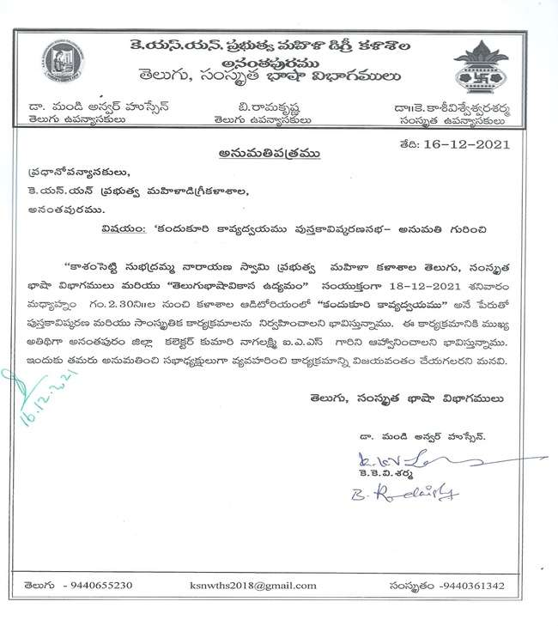

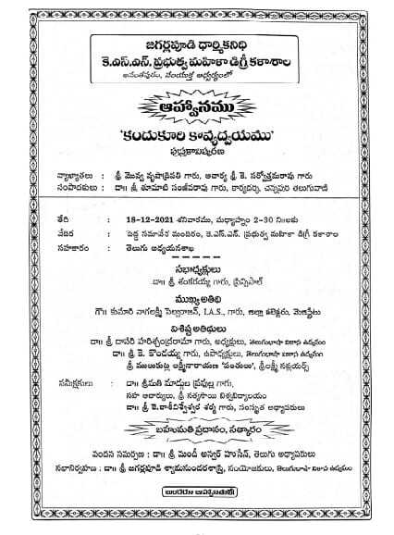

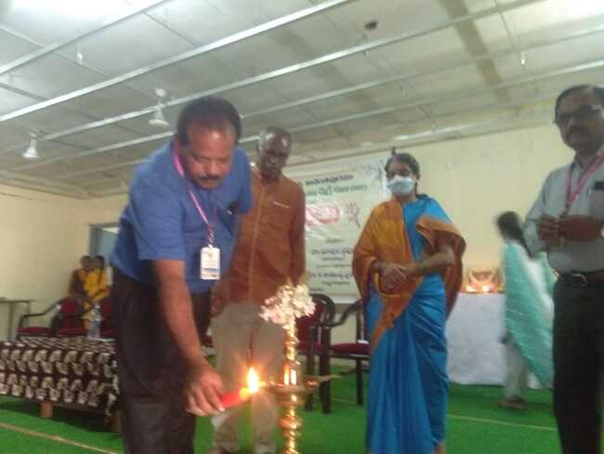

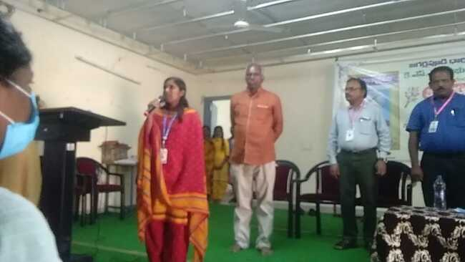

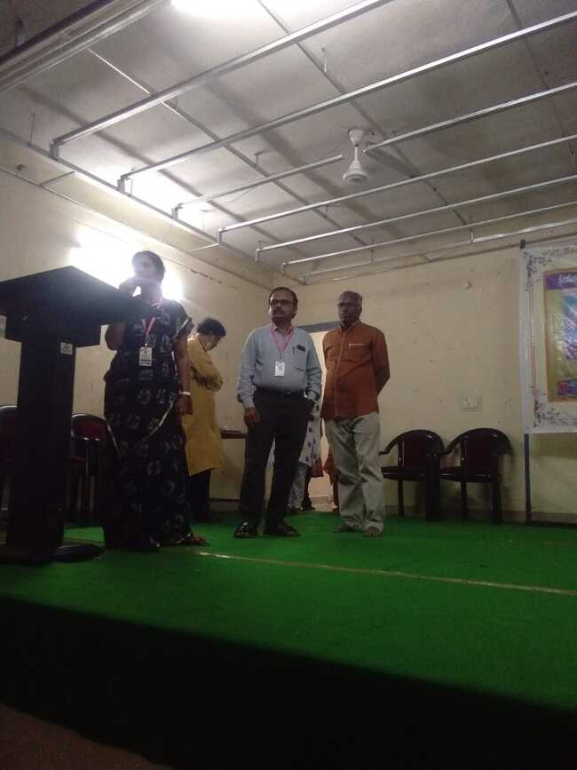

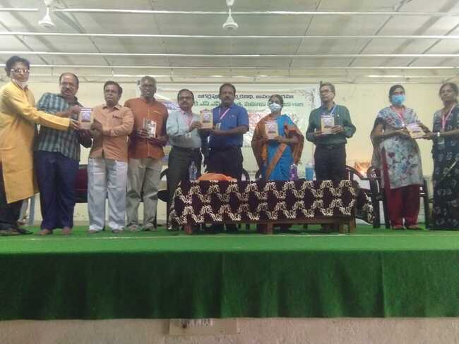

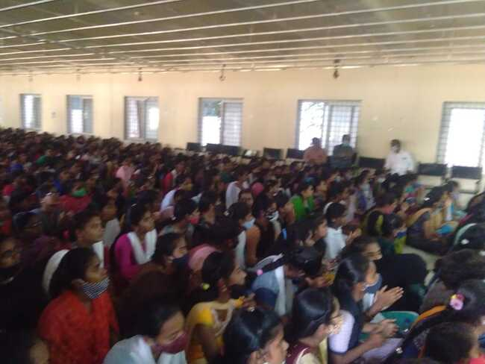

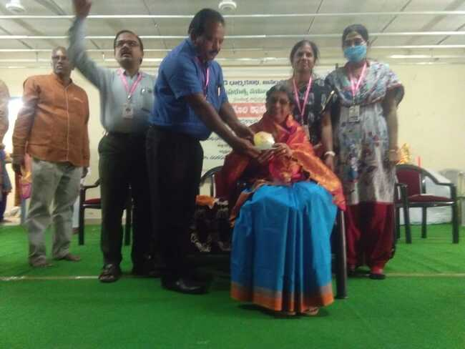

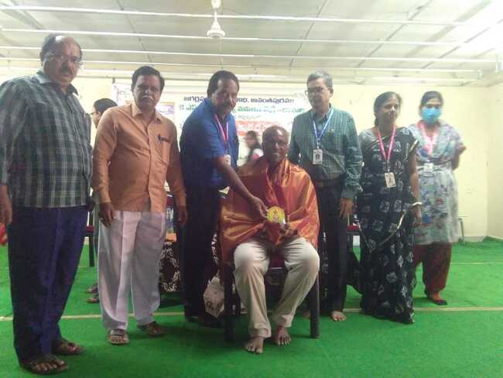

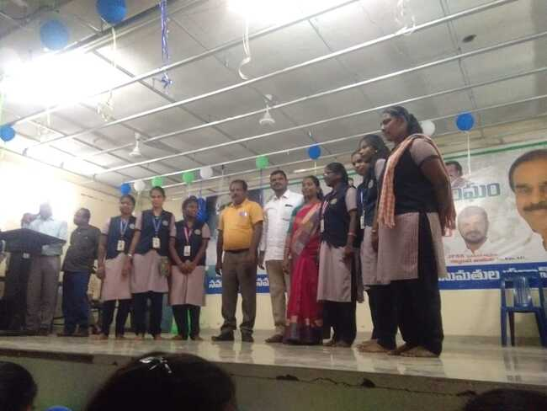

**In part of Azaji Amruta mohotsvam Jawahar Nehru yukaka kendram arranged a essay writing and Elocution competition on 12th January**

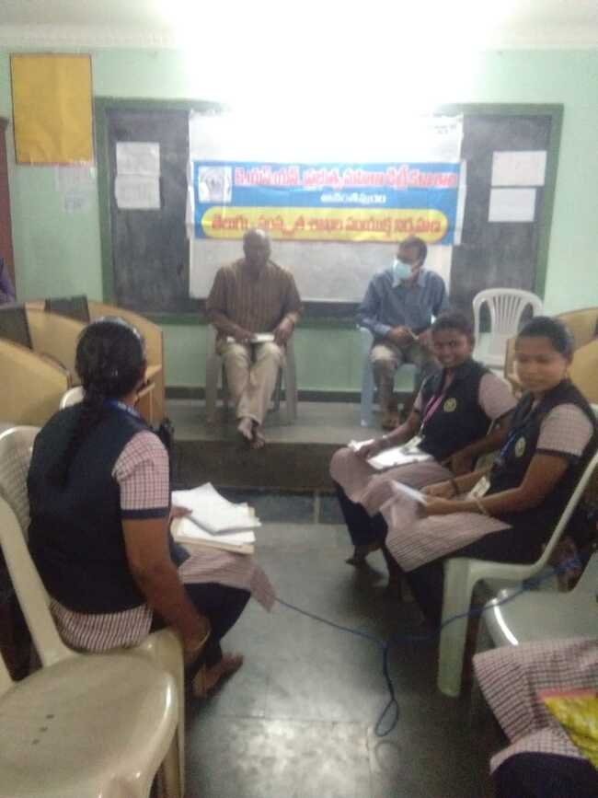

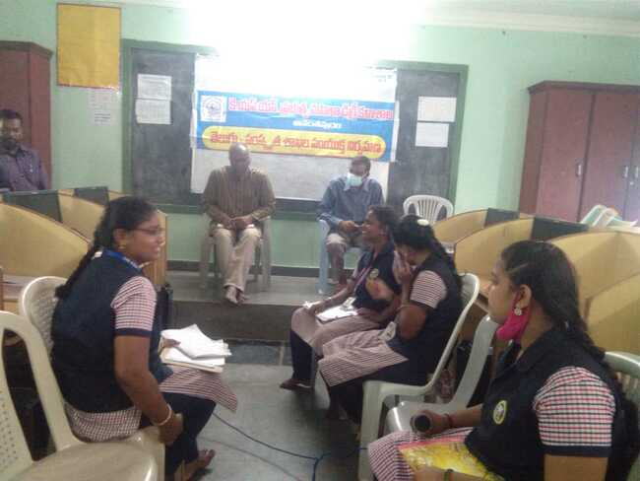

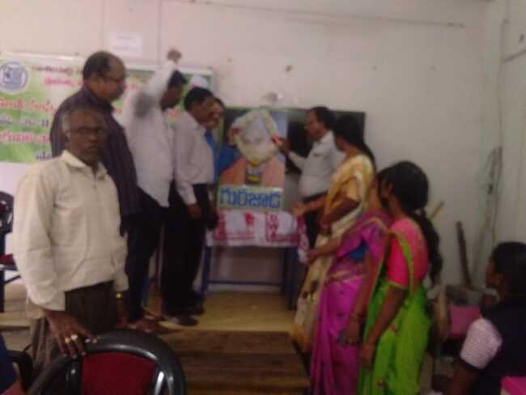

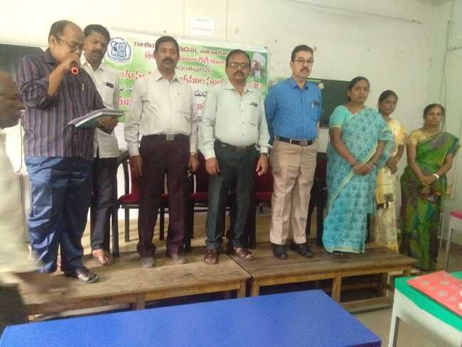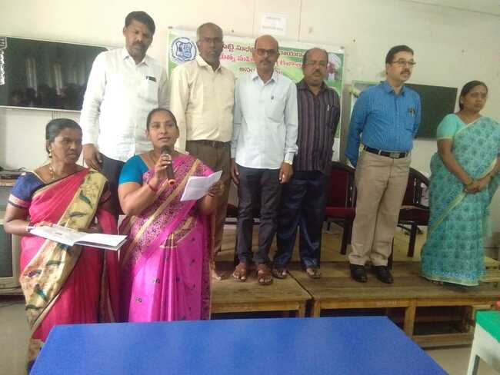

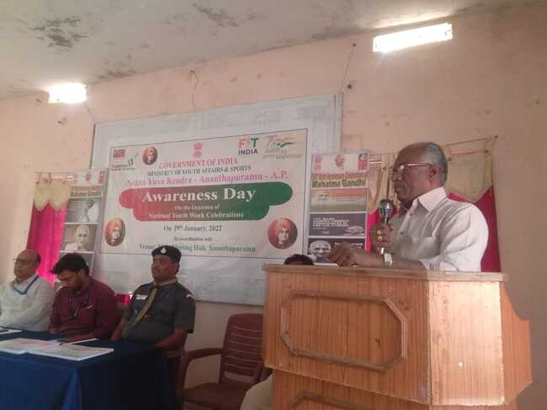

**c**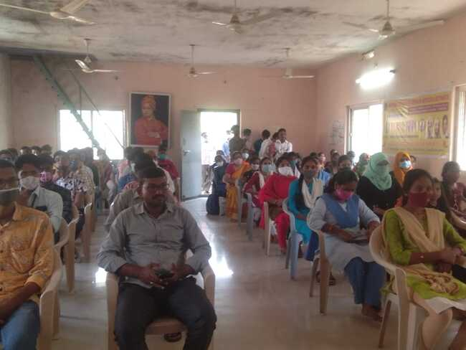

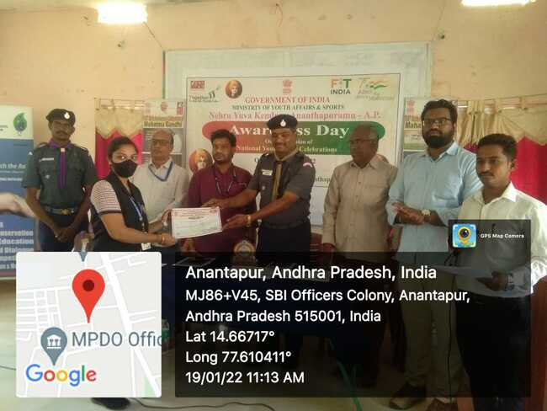

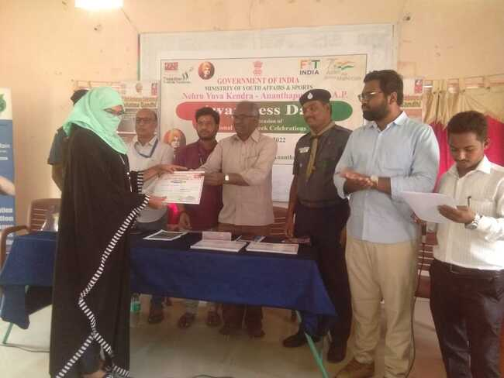

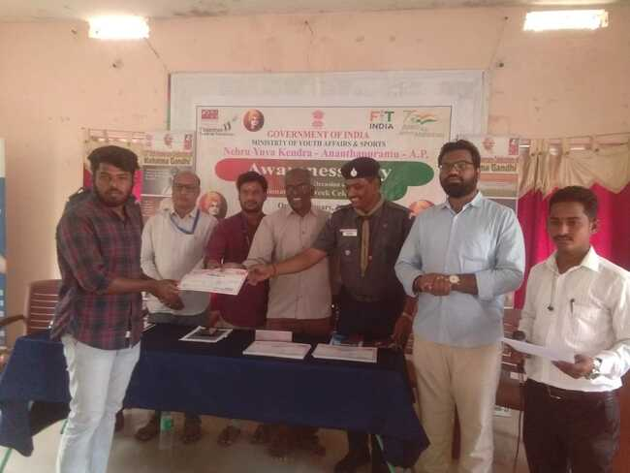

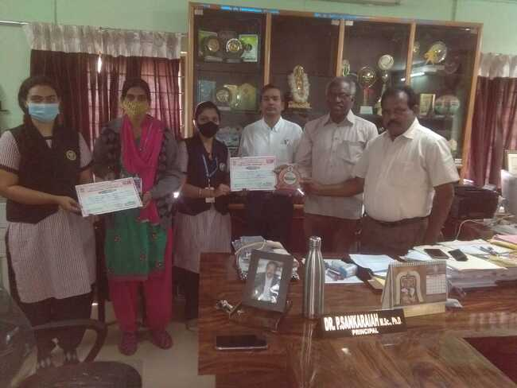

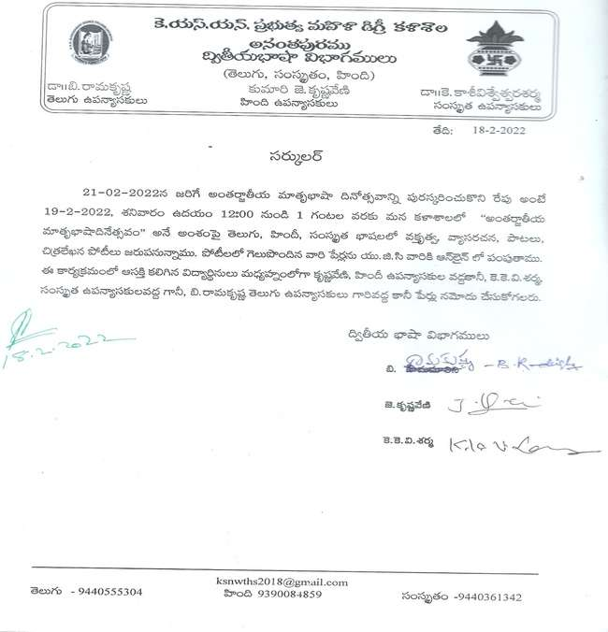

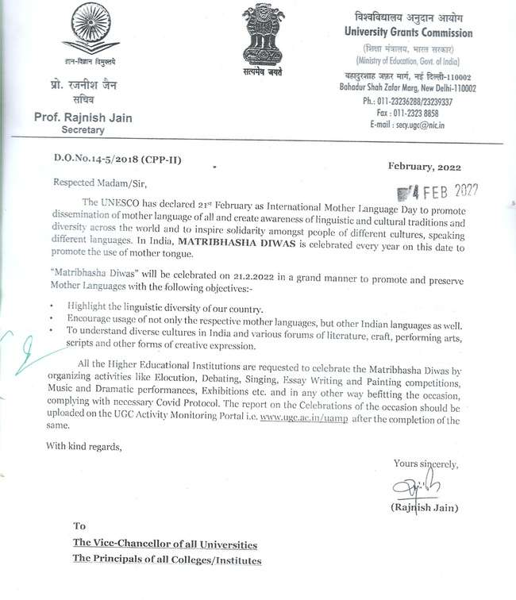

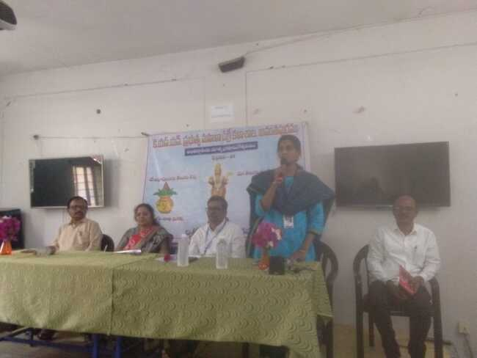

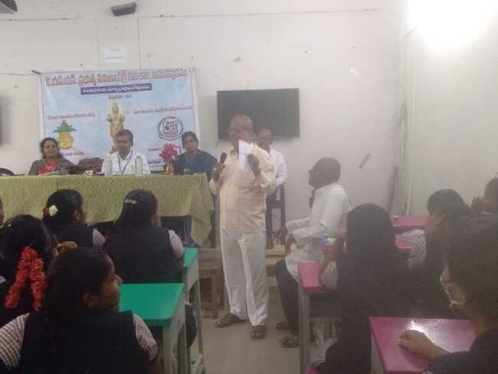

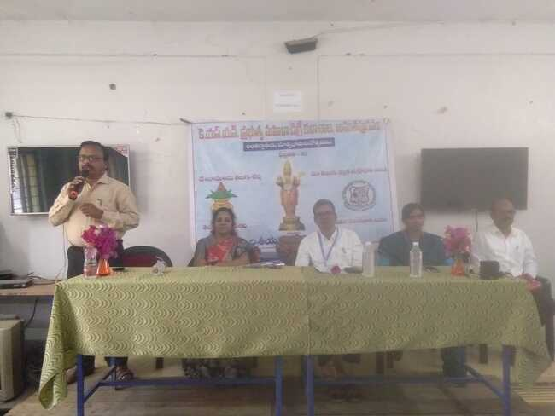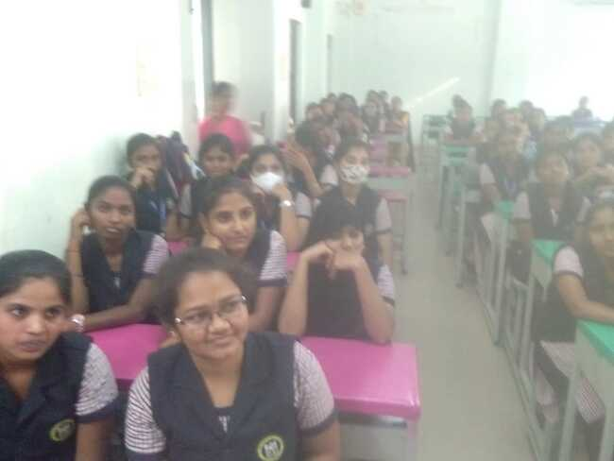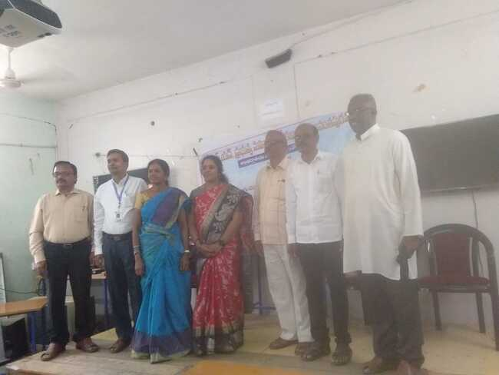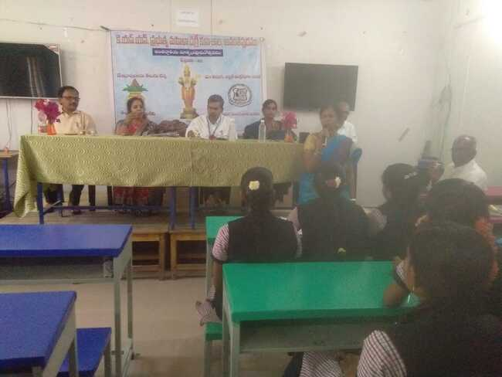

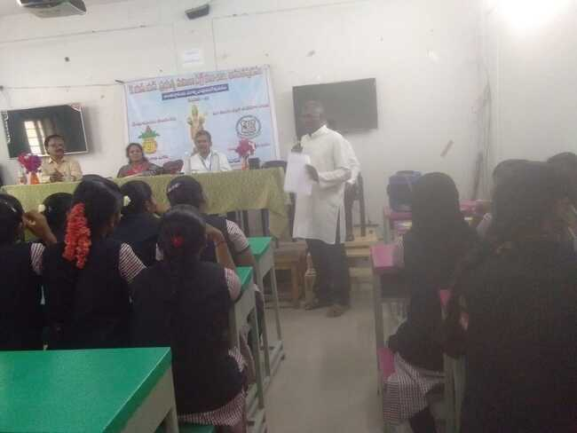



2021-22